Deploy de un Modelo de IA en Cloud Kubernetes

La ejecución de Docker ofrece a desarrolladores y administradores una manera muy confiable y económica de **crear, enviar y ejecutar** aplicaciones distribuidas en cualquier escala.

Docker es una plataforma de software que permite **crear, probar e implementar** aplicaciones rápidamente. Docker empaqueta software (una aplicación) en unidades estandarizadas llamadas *contenedores* que incluyen todo lo necesario para que el software (la aplicación) se ejecute, incluidas bibliotecas, herramientas de sistema, código y tiempo de ejecución. Con Docker, puede **implementar y ajustar la escala** de aplicaciones rápidamente en cualquier entorno con la certeza de saber que su código se ejecutará.

Un contenedor de Docker es una imagen de Docker instanciada (en ejecución). Una imagen de Docker es una plantilla de solo lectura que define su contenedor. La imagen contiene el código que se ejecutará, incluida cualquier definición para cualquier biblioteca o dependencia que el código necesite.

Docker es un sistema operativo para contenedores. Los contenedores virtualizan el sistema operativo de un servidor[1]. Docker se instala en cada servidor y proporciona comandos sencillos que puede utilizar para crear, iniciar o detener contenedores.

Kubernet…..

Workflow

[Workflow](https://codefresh.io/learn/github-actions/github-actions-workflows-basics-examples-and-a-quick-tutorial/)

## **What is container orchestration?**

[Containers](https://www.cio.com/article/247005/what-are-containers-and-why-do-you-need-them.html) allows to run reliably when moved from one computing environment to another by packing of an entire runtime environment: an application, plus all its dependencies, libraries and other binaries, and configuration files needed to run it. By containerizing the application platform and its dependencies, differences in OS distributions and underlying infrastructure are abstracted away.

## Large, distributed containerized applications can become increasingly difficult to coordinate. By making containerized applications dramatically easier to manage at scale, Kubernetes has become a key part of the container revolution.

## **Kubernetes**

In a containerized architecture, the different services that constitute an application are packaged into separate containers and deployed across a cluster of physical or virtual machines. But this gives rise to the need for *container orchestration*—a tool that automates the deployment, management, scaling, networking, and availability of container-based applications.

[Kubernetes](https://kubernetes.io/) is an open source platform for **container orchestration** that allows to deploy and manage applications built out of multiple self-conteined runtimes called containers. Mostly often used with [Docker](https://www.infoworld.com/article/3204171/what-is-docker-the-spark-for-the-container-revolution.html), container platform. It can be used freely by anyone who wants to run containers, most anywhere they want to run them—on-premises, in the public cloud, or both.

## **CI/CD**

Continuous Integration and Continuous Delivery/Deployment (CI/CD) is a software engineering practice that **automates application build, testing, and deployment**. CI/CD practices form the backbone of modern DevOps processes.

**GitHub Action**

GitHub Actions is a platform for continuous integration / continuous delivery ([CI/CD](https://codefresh.io/learn/ci-cd/)). It enables you to **automate** build, testing, and deployment pipelines. It also lets you run arbitrary code on a specified repository when an event occurs.

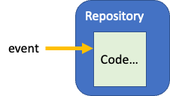

Actions uses code packages in Docker containers that run on GitHub servers.

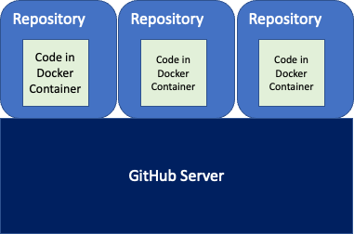

They are compatible with all programming languages to ensure you can run them on public clouds as well as local servers.

**Chapter: Initialize Workflow on GitHub**

1.- Create Repository on GitHub (<https://github.com> )

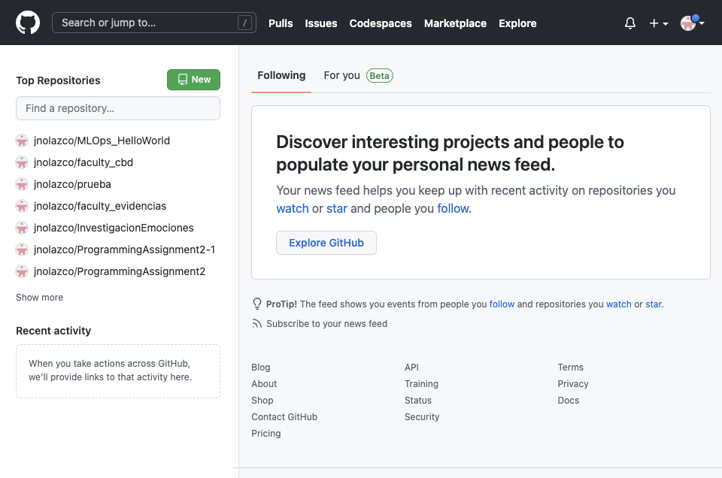

1.1.- On section **Top Repositories** (left side of the page) click on **New**.

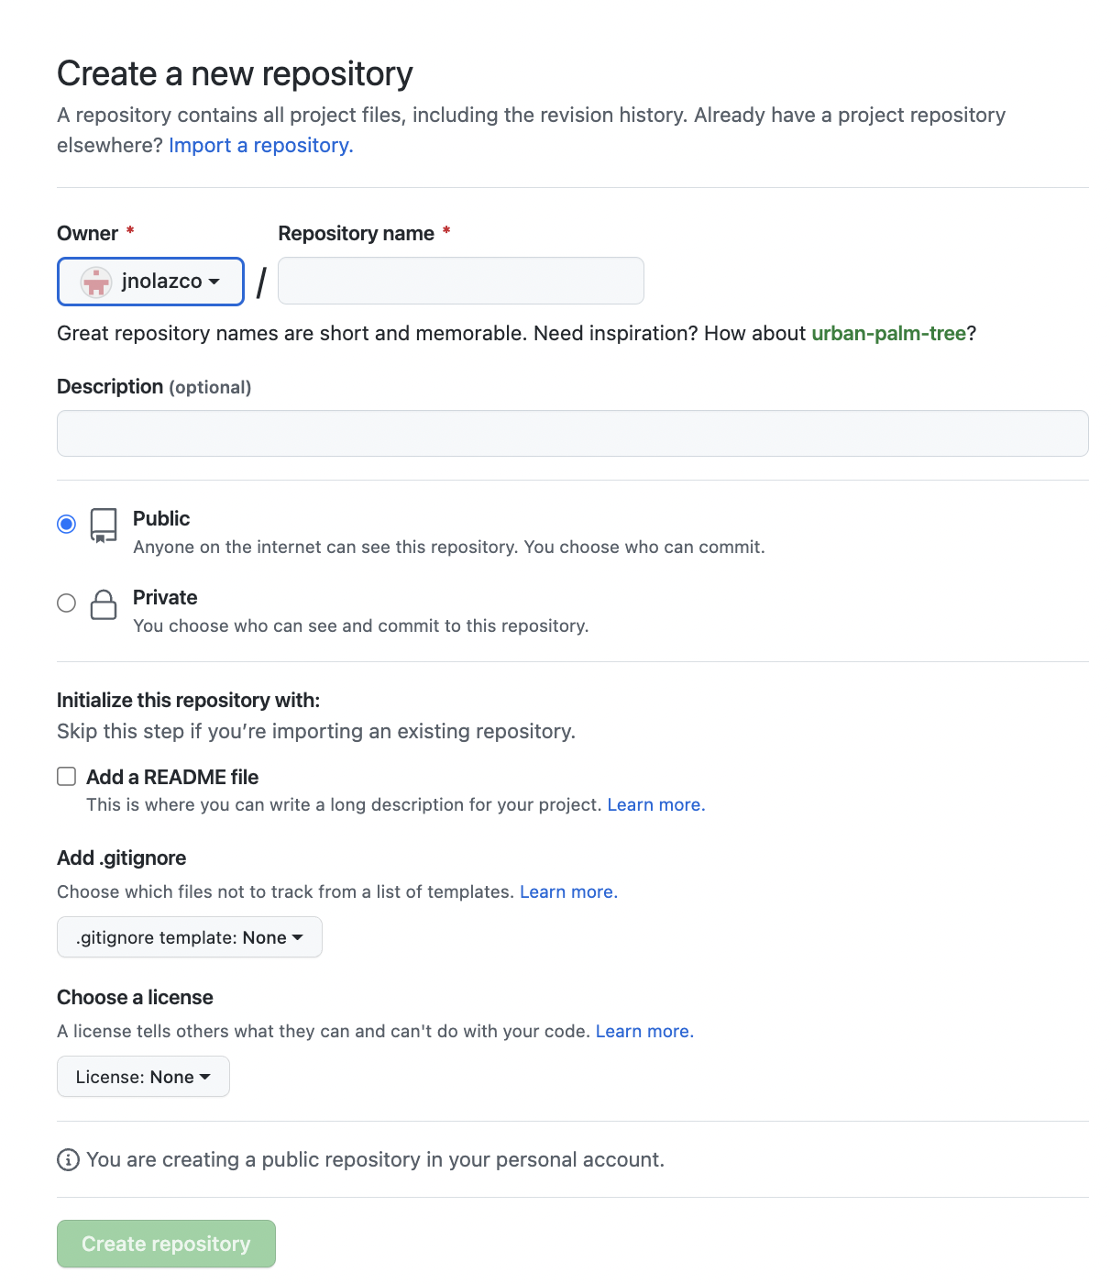

Figure 1. Form in github to create a repository.

1.2.- Give a name to the Repository, in this case we are calling **myMLOps_Hello-World**.

1.3.- Fill Description, i.e. “Deploy data-driven model on Kubernet”.

1.4.- Set repository as **public.**

1.5.- click on “**Add a README file**” option.

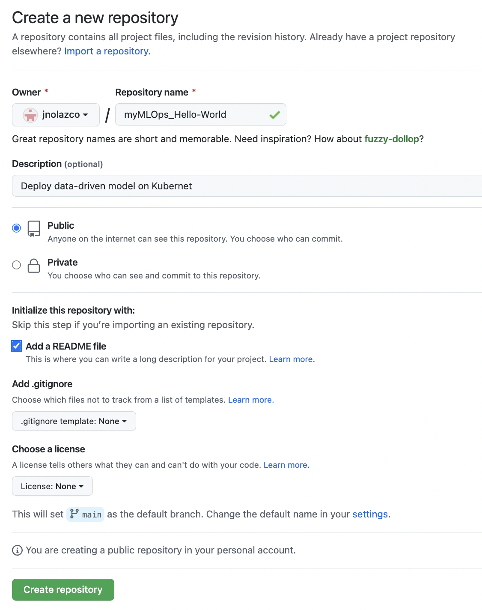

Figure 2. Filling data to create repository **myMLOps_Hello-Wolrd**.

1.6.- click on button “**Create Repository**”, and the output is shown in figure 3.

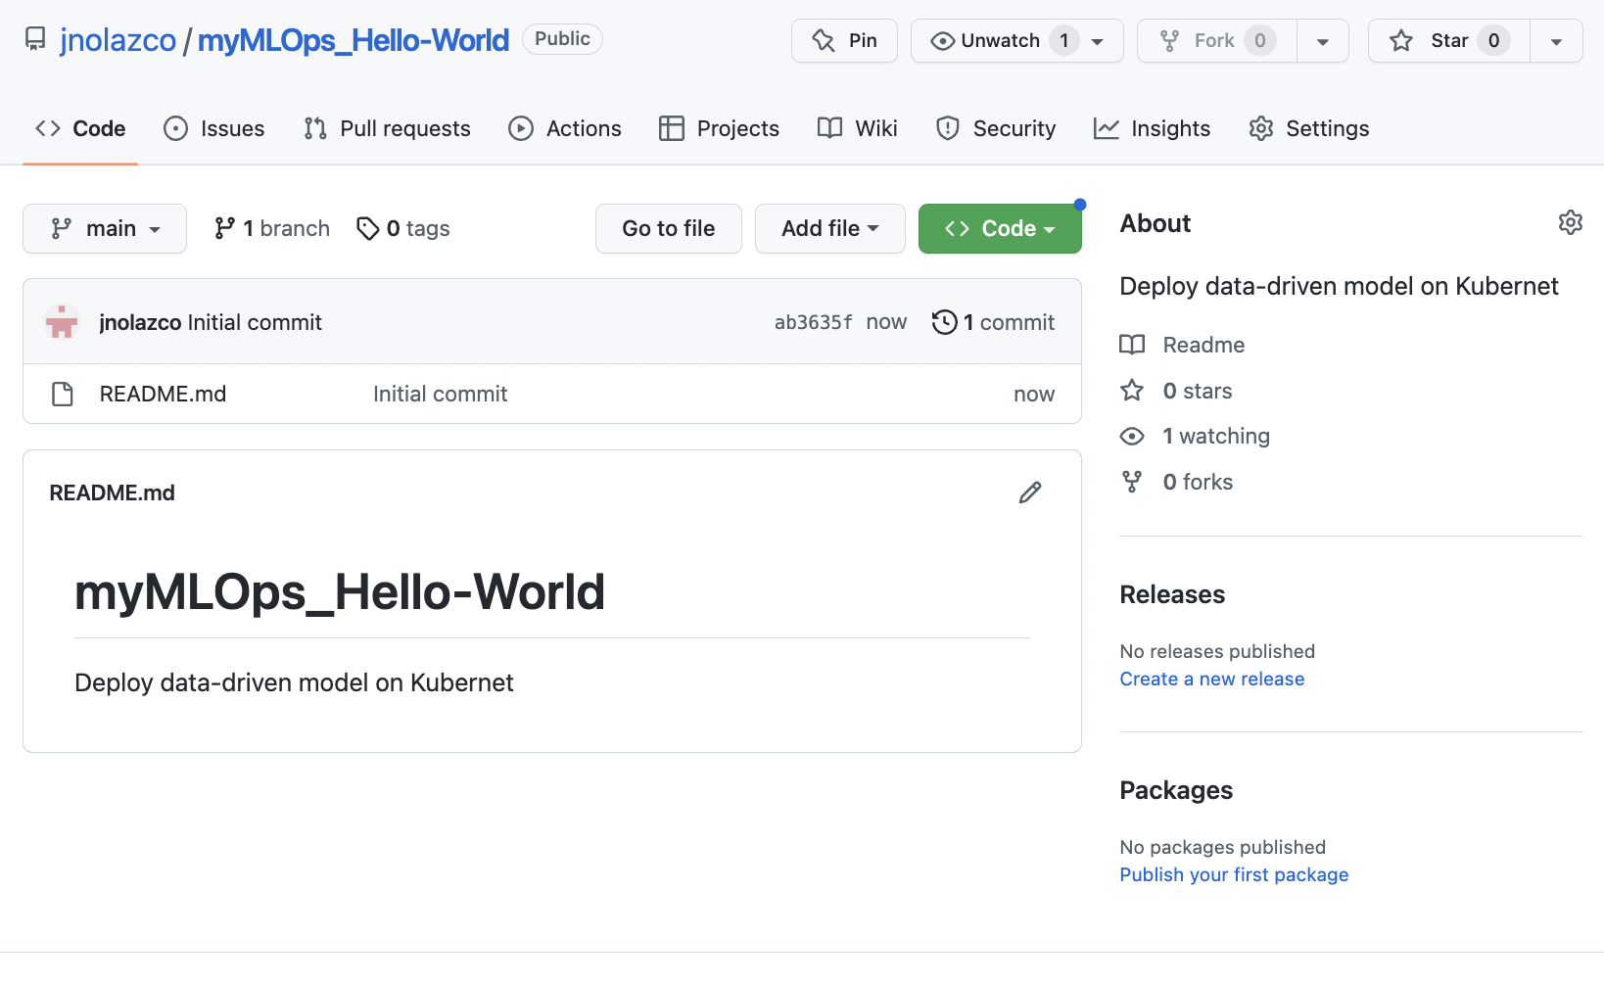

Figure 3. Repository **myMLOps_Hello-Wolrd**.

**2. Create a Simple Workflow for this repository on GitHub**

A workflow is a configurable automated process made up of one or more jobs. You must create a YAML file to define your workflow configuration.

The purpose of this initial version of the Workflow is to create a Workflow that

1. setups the Operating Systems used
2. indicates that automatically trigger a workflow when the push event occurs
3. runs an echo command to write “Hello World”.

2.1.- Click on ***Actions*** of the repository **myMLOps_Hello-World** (figure 3).

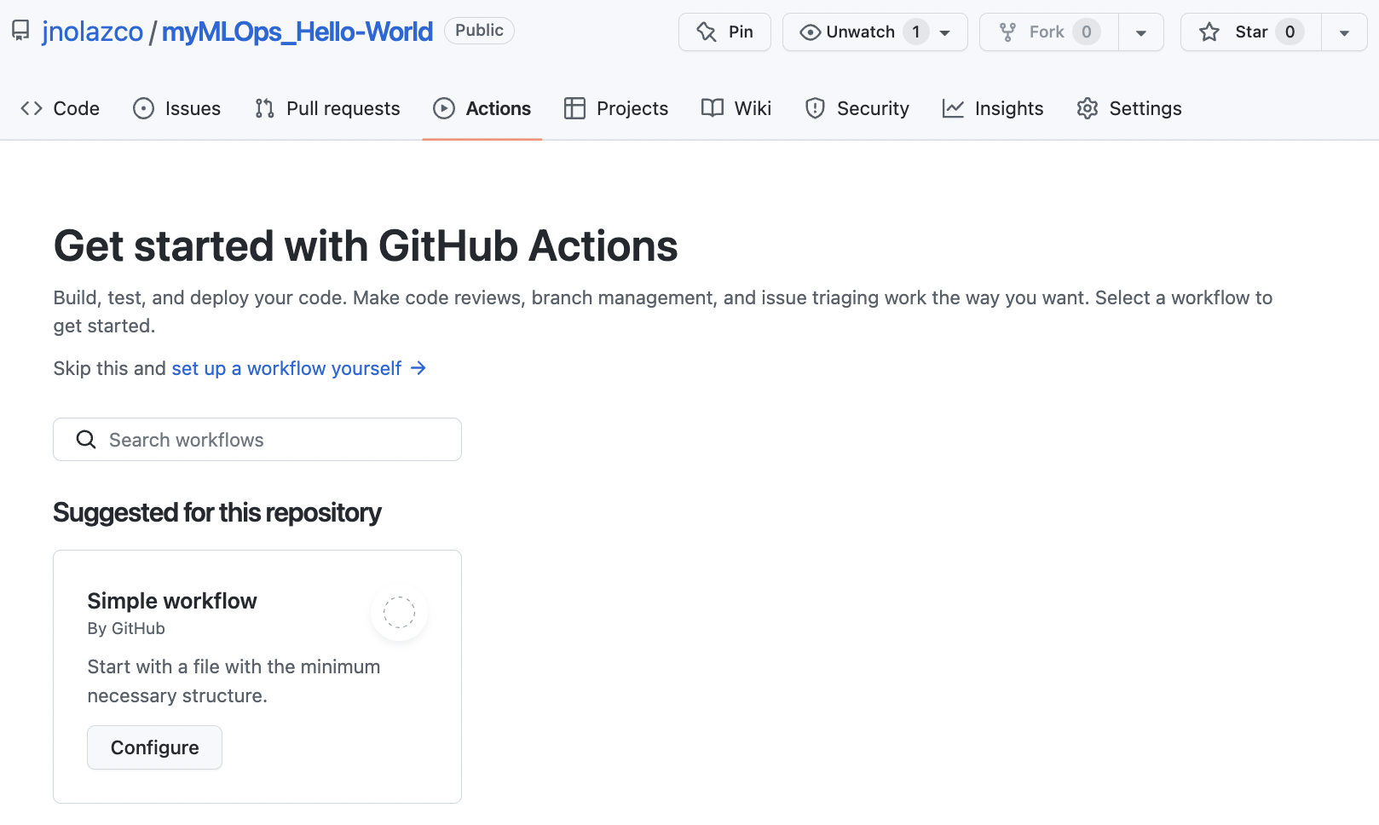

Figure 4. Button to create a Workflow.

2.2.- Click on **Configure** (Figure 4).

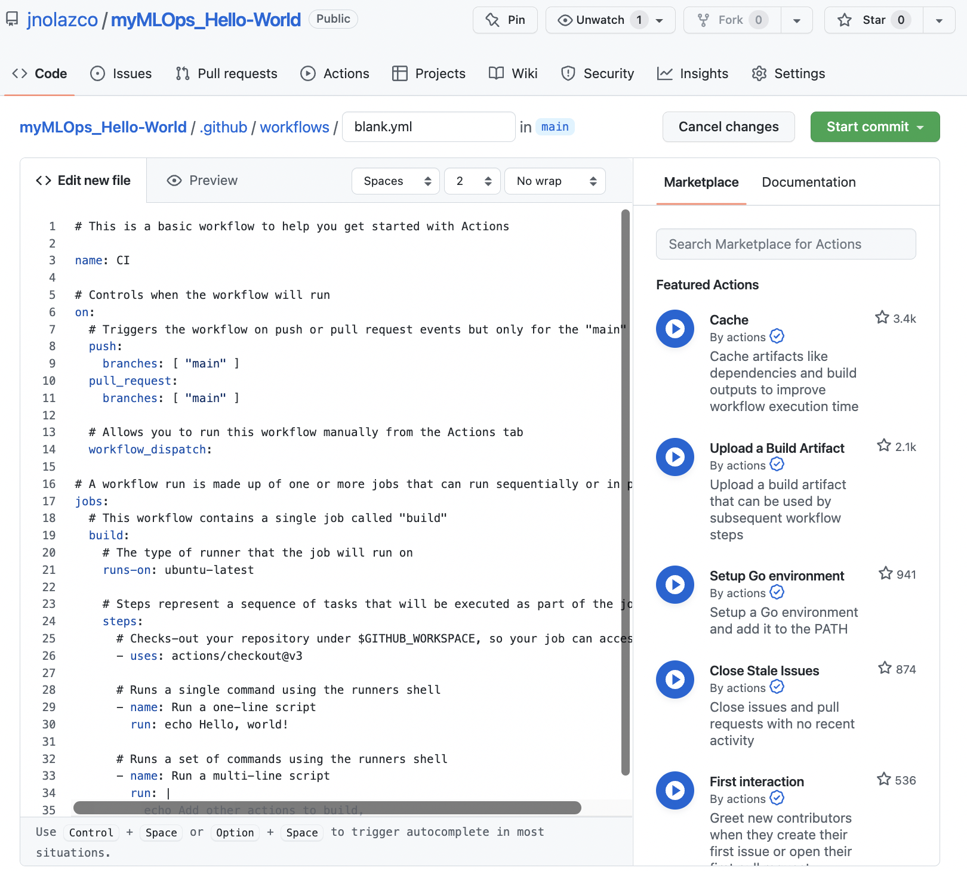

2.3.- In figure 5, fill the spaces after “myMLOps_Hello-World/.github/workflows/” with the workflow name, in this case we will use the name **myMLOps_Hello-World.yml.**

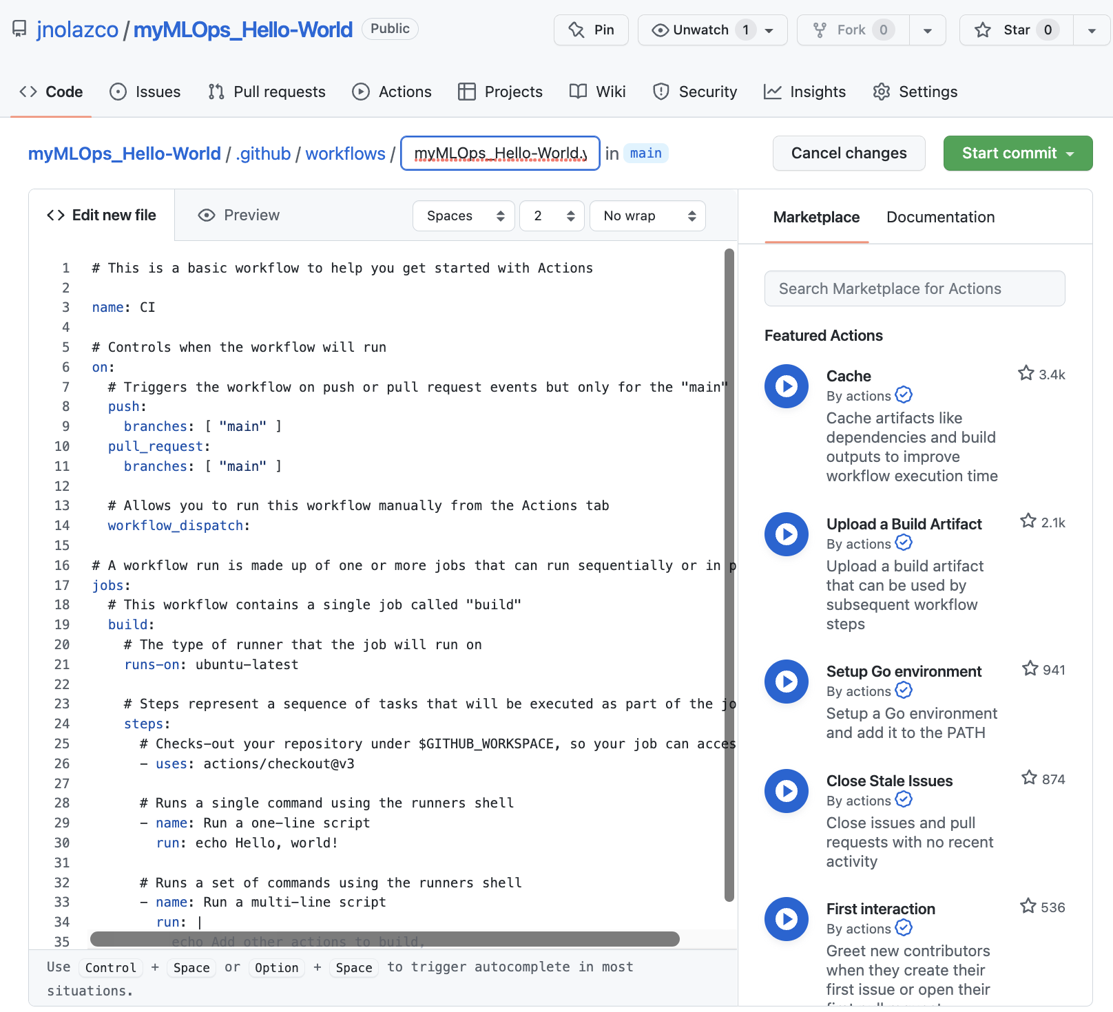

Figure 3. Workflow coding space.

2.4.-Replace content of section **“Edit new file”** with the yml code needed to perform next actions:

1. setups the Operating Systems used
2. indicates that automatically trigger a workflow when the push event occurs
3. runs an echo command to write “Hello World”.

start Ubuntu and copy repository to the container (Annex A).

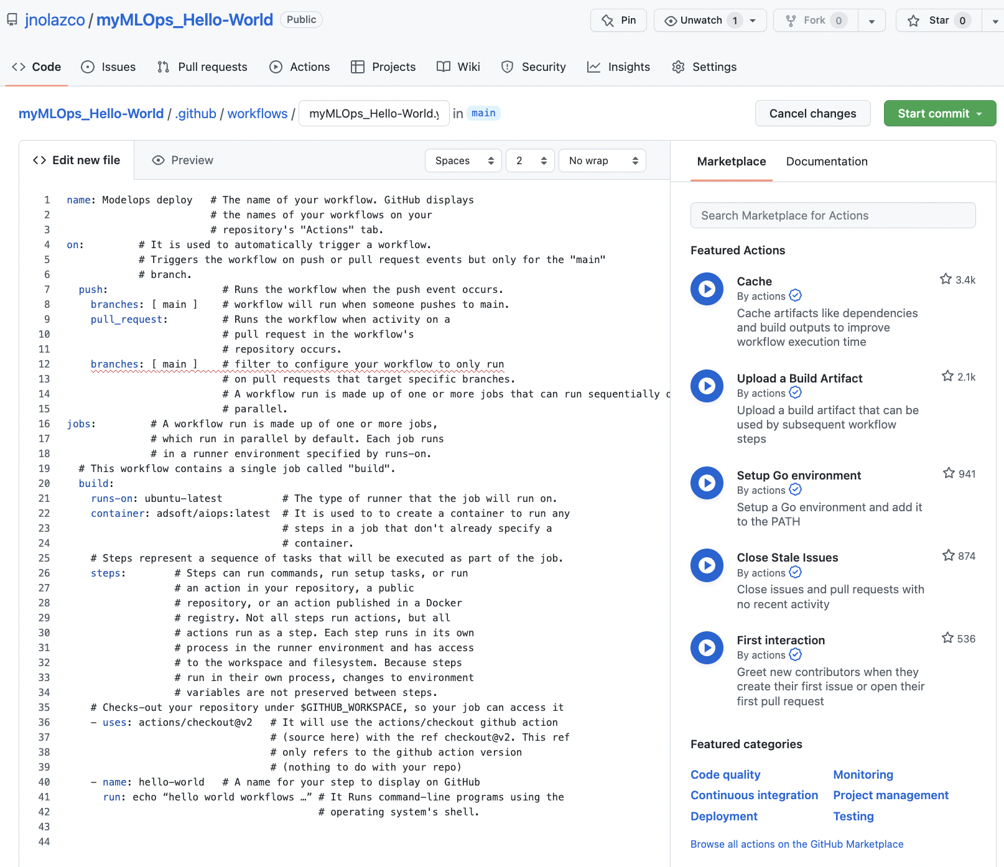

3.- **Trigger the workflow:**

3.1.- Click on the button ***Start Commit***, (figure 4) and opens a small form, just below the button, to fill the Commit new file

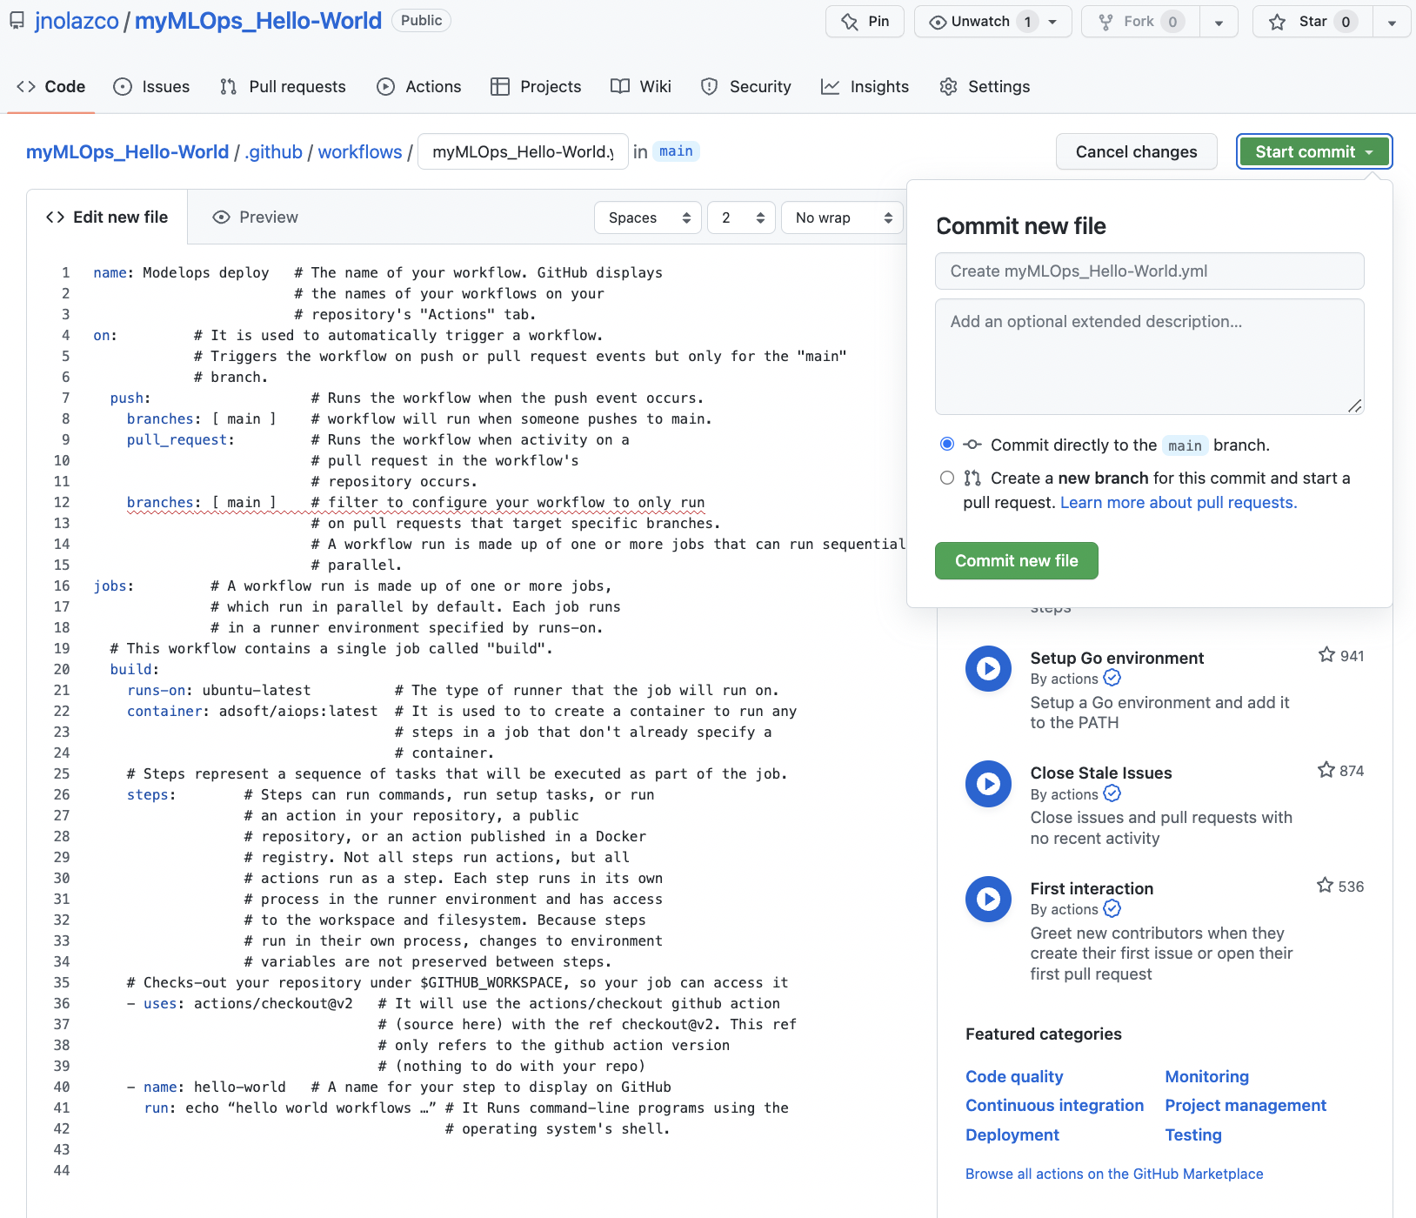

3.2.- In figure 5, the form “**Commit new file**” form has two fields to fill. We fill the first field with a message related to the Workflow function for the commit, in this case we will use the name **First step of the Workflow construction** and we fill the extended description with **Hello World**.

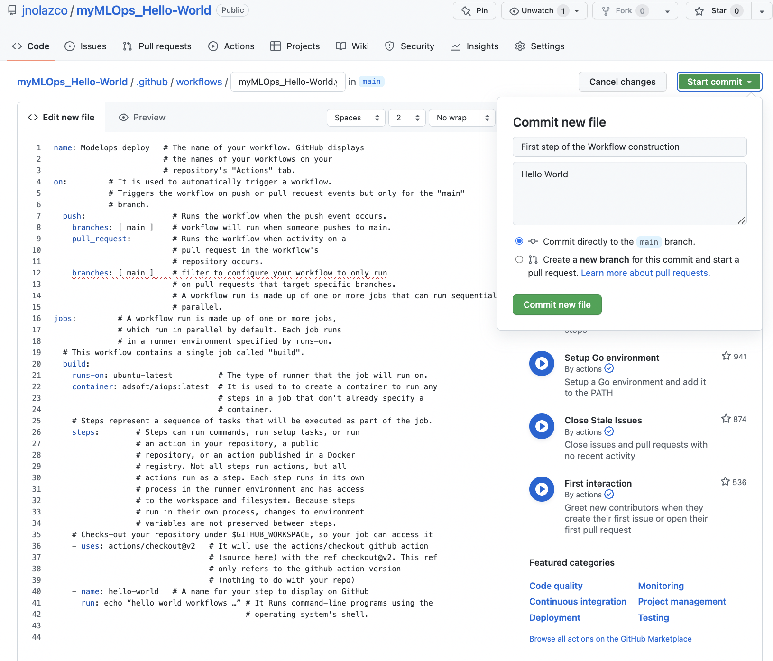

Figure X. Commit name specification.

3.3.- Save changes by *clicking* on ***Commit Changes***. At present, we finish the first step of the Workflow Construction

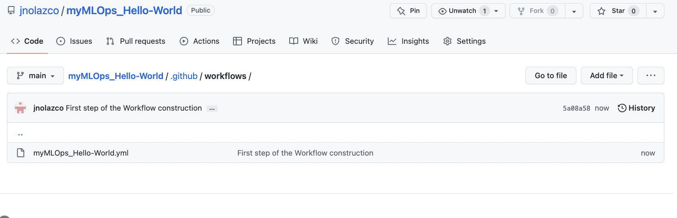

Figure X. Commit name specification.

4.-Verify that Workflow was automatically triggered:

Since in our workflow we specify that is automatically triggered, we can verifying following next steps.

4.1.- On main menu of the repository **myMLOps_Hello-World**, click on ***Actions***

4.2.- In section “All workflows”, figure 6, you will observe workflow run “**Workflow para MLOps HelloWorld**”.

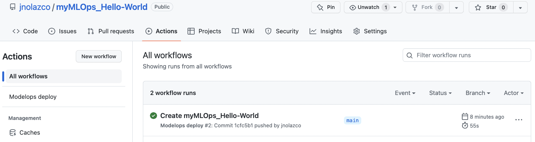

Figure 6. Commit name specification.

5.- Step-by-step workflow execution

5.1 click on the last Workflow we execute (first on the list), in this case “**Workflow para myMLOps HelloWorld**” (Figure 7).

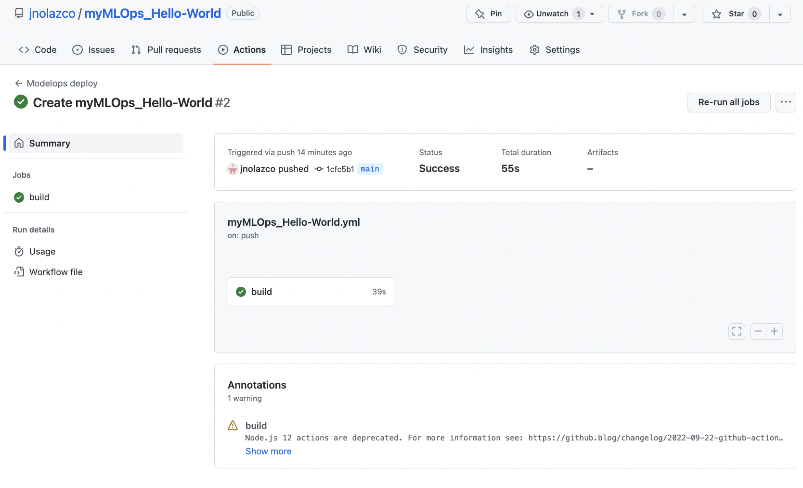

Figure 7. “Workflow para MLOps HelloWorld” execution.

5.2 click on button ***build***, to run a step-by-step execution of the workflow (figure 8)

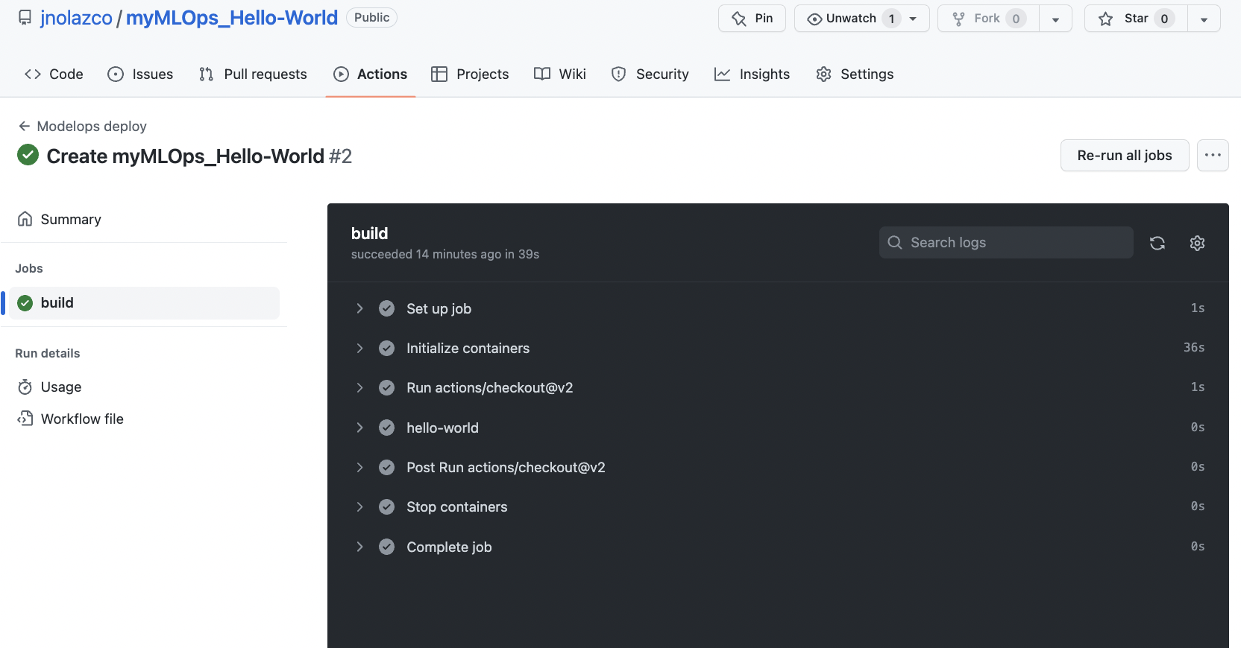

Figure 7. Workflow step-by-step execution.

5.3.- We can click on “hello-world” and we will se more details

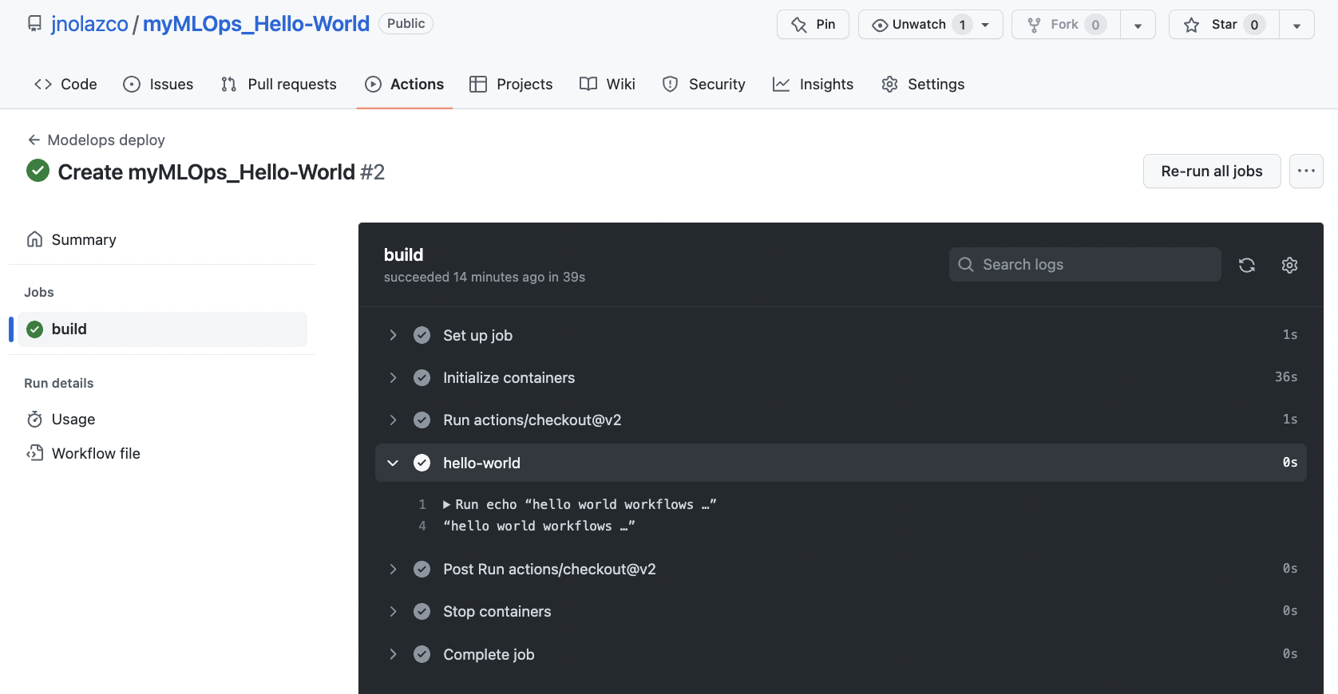

Figure X. Workflow step-by-step execution.

Note: Si por alguna razón algun paso falla se interrumpe la ejecución y tenemos que regresar al paso 4, para hacer las correcciones adecuadas.

**Nota 2:** cada paso contiene muchos comandos que GitHub nos facilita para crear esta Máquina Virtual Docker.

**1. Create the code file of the data model, for** repository **myMLOps_Hello-World,**

In this case the code file is named “linear-model.py”, which means that for this laboratory our model is linear.

1.1.- Starting on main menu repository **myMLOps_Hello-World**, clicks on buttons: ***<Code> -> Add File -> Create New File*** to have the form to create a file (figure 9)

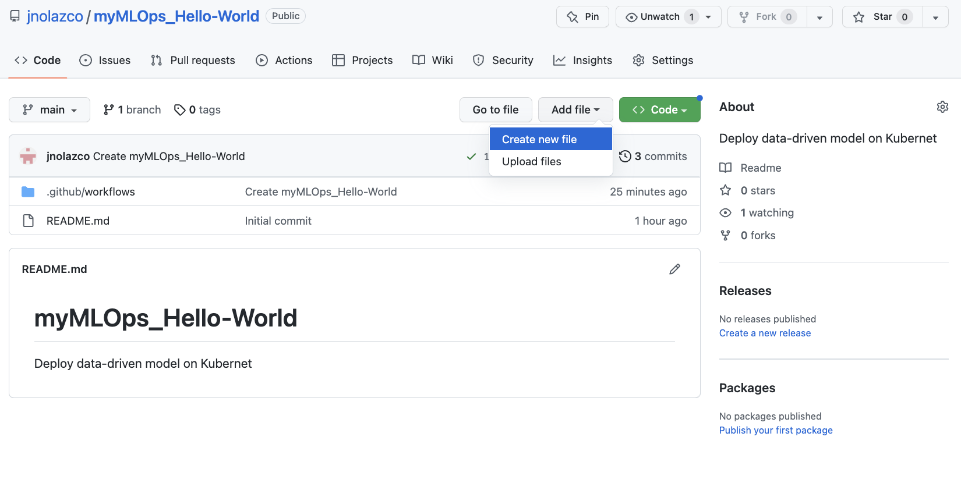

Figure 9. Commit name specification.

1.2.- In figure 10, fill the spaces after “[**myMLOps_Hello-World**](https://github.com/jnolazco/myMLOps_Hello-World)**/**” with the code’s file name, in this case we will use the name **linear-model.py**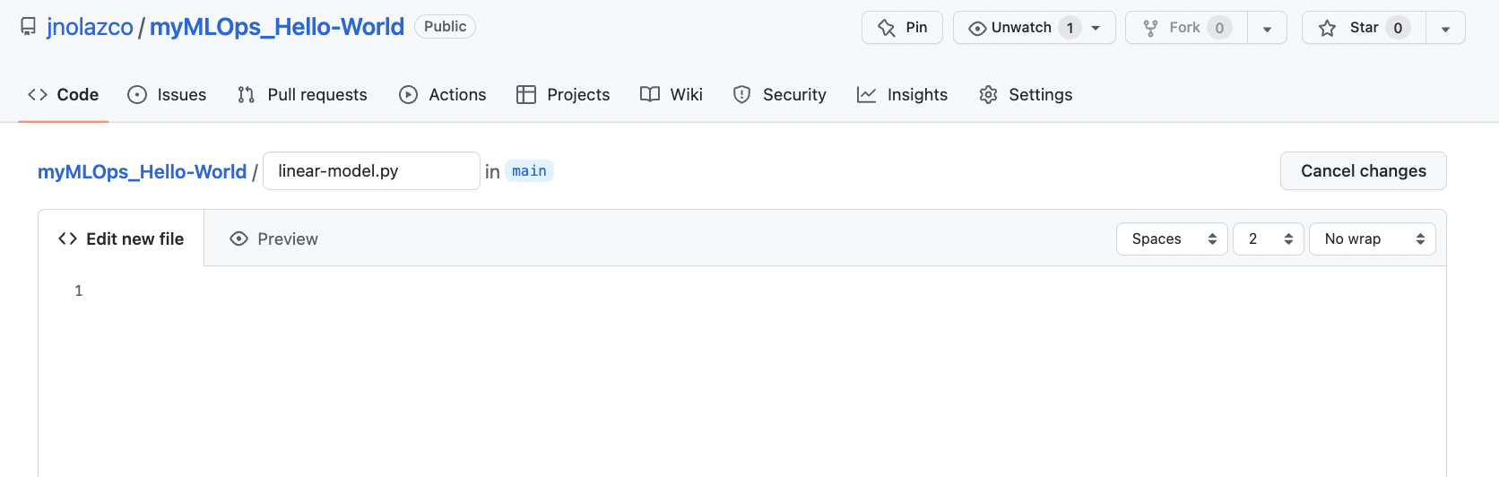

Figure 10. Form to create a <Code> file.

1.3.-Replace content of section **“Edit new file”**, figure 11, with the Python code that performs next actions (Annex B):

1. trains a linear model
2. predicts values given the trained model

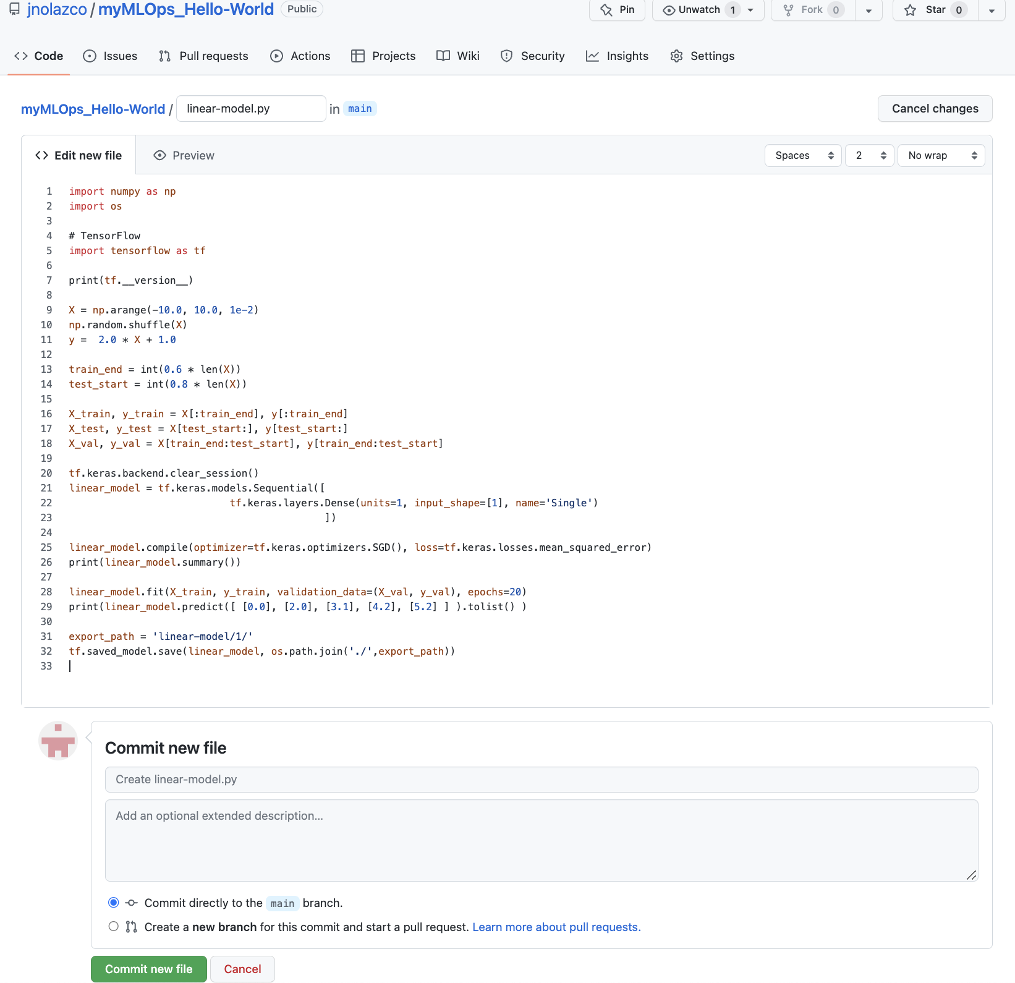

Figure 11. <Code> file that train a linear model and predict some values.

1.4.- At section “**Commit New File**” (located at the end of section **“Edit new File”**) fill a comment on blank spaces, in this lab we writedown “Create linear-prediction model”;

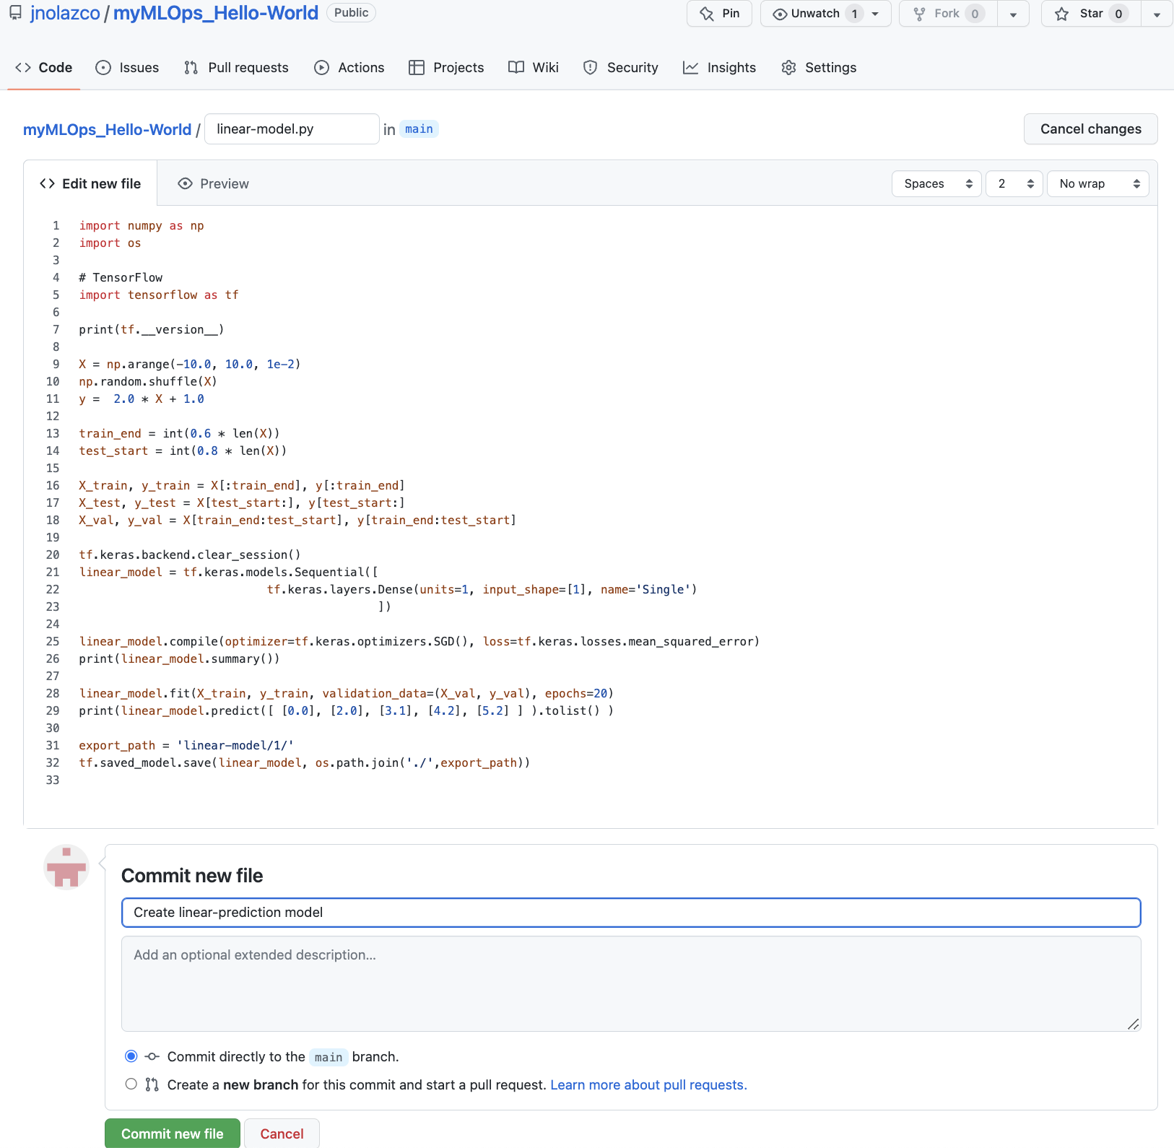

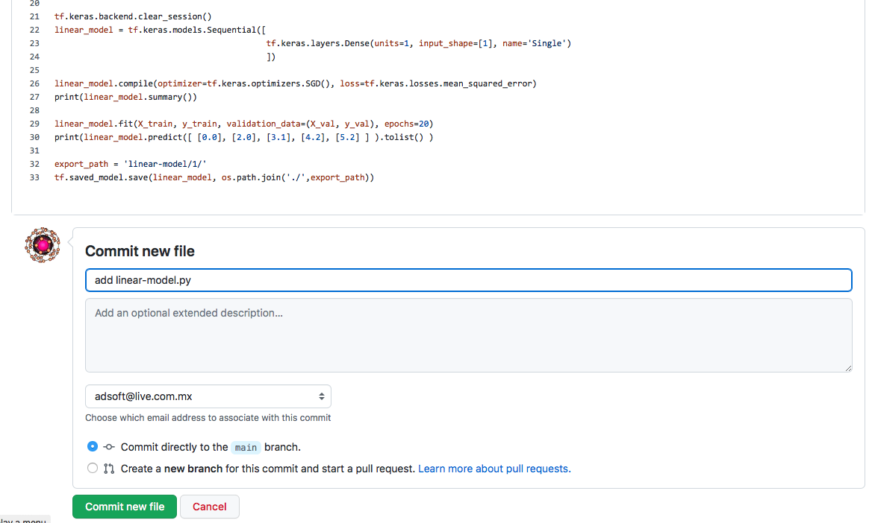

Figure 12. Commit name specification.

1.5.- save file by clicking on button “***Commit new file***”.

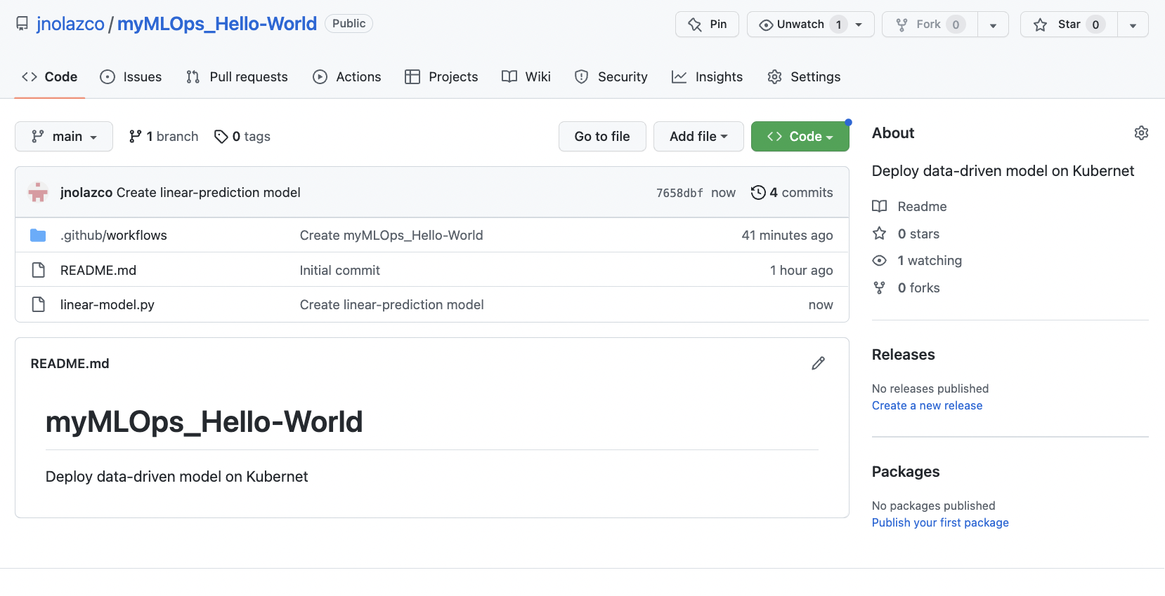

Chapter: Integrate **linear-model.py** to Workflow modelops.yml:

1.1 Append next two lines on workflow modelops.yml (access it by clicking on main menu: **<Code>**

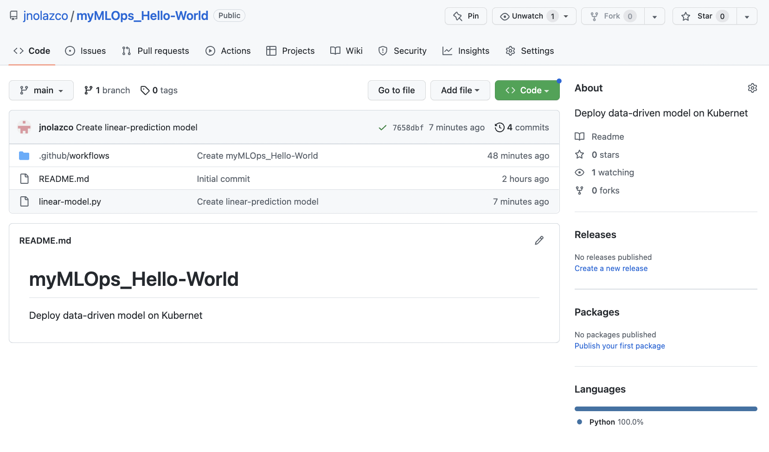

1.2 Click on carpet **.github/workflows**

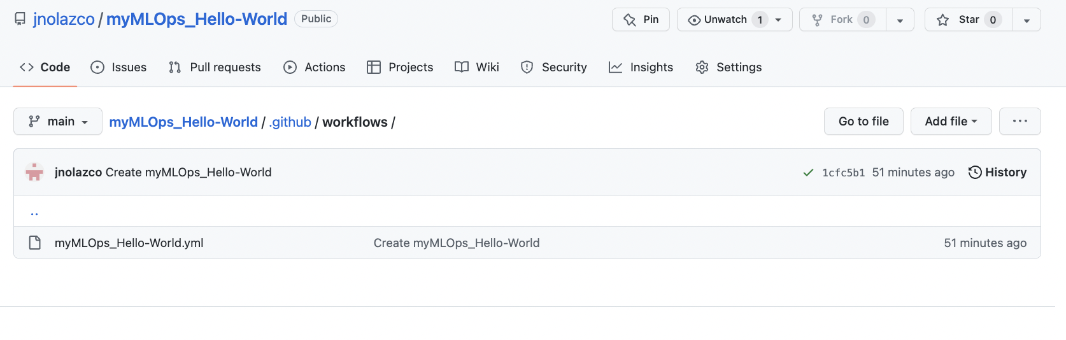

1.3 Click on **modelops.ym** file

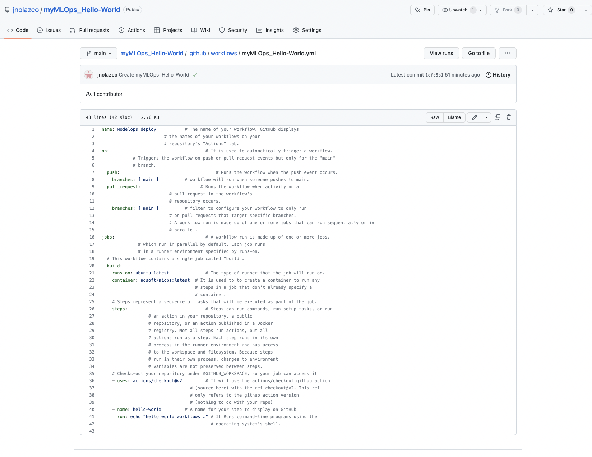

1.4 Click on **Edit ()** and append next two lines of yml code(Note: take care of indentation):

- name: run model

run: python linear-model.py

as shown below:

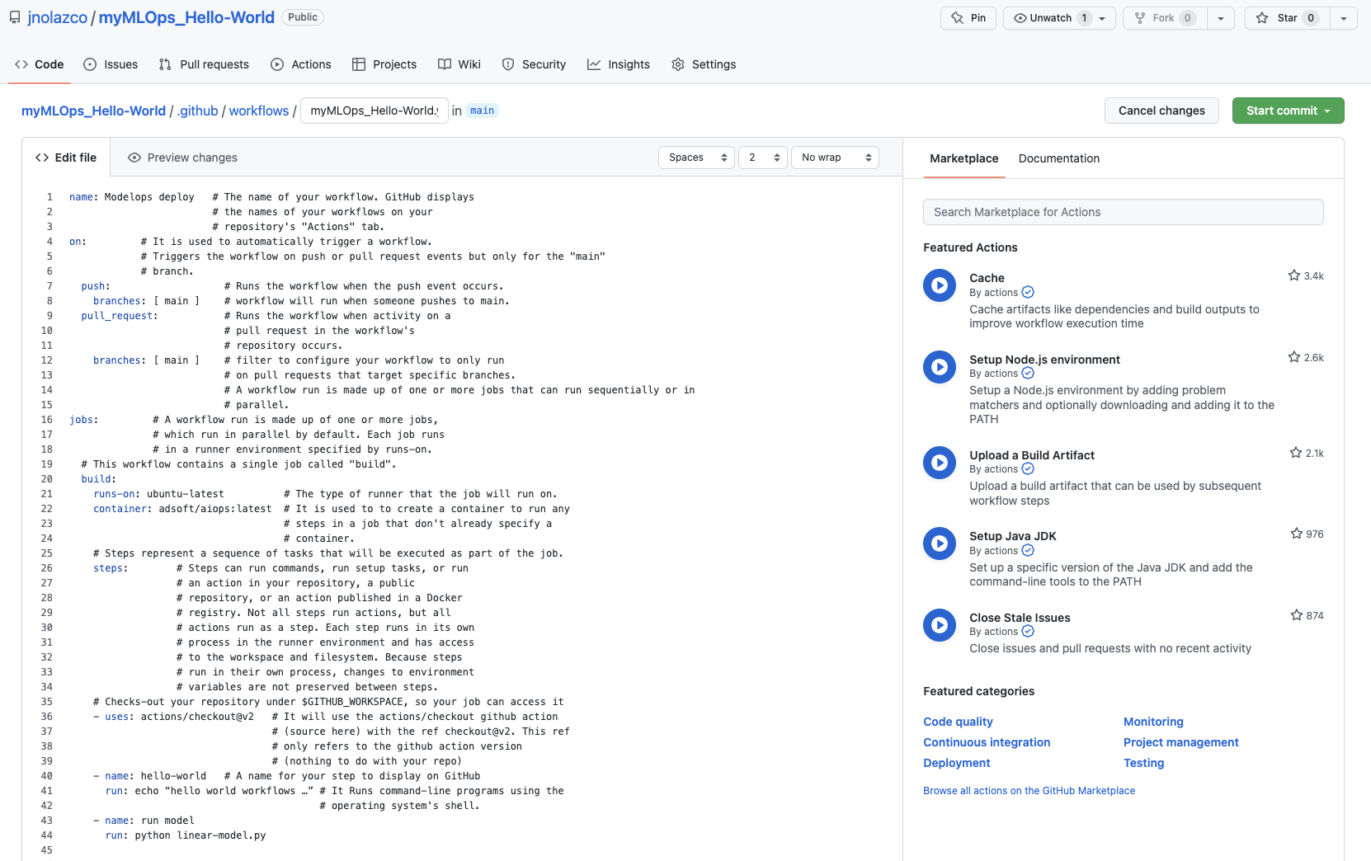

Figure 13. Commit name specification.

2.- Save changes:

2.1.- Click on the button ***Start Commit***, (figure 4) and opens a small form, just below the button, to fill the Commit new file

2.2.- Add a comment related to the Workflow function

2.3.- save change by *clicking* on ***Commit Changes***.

Nota: como realizamos una acción, el workflow se dispara automáticamente. En este caso, la acción fue ejecutar el programa “**linear-model.py**”

3.-Verify that Workflow was automatically triggered:

Since in our workflow we specify that is automatically triggered, we can verifying following next steps.

3.1.- On main menu, click on ***Actions***

3.2.- In section “All workflows”, figure 13, you will observe workflow run “**Ejecución de la Regresion Lineal**”.

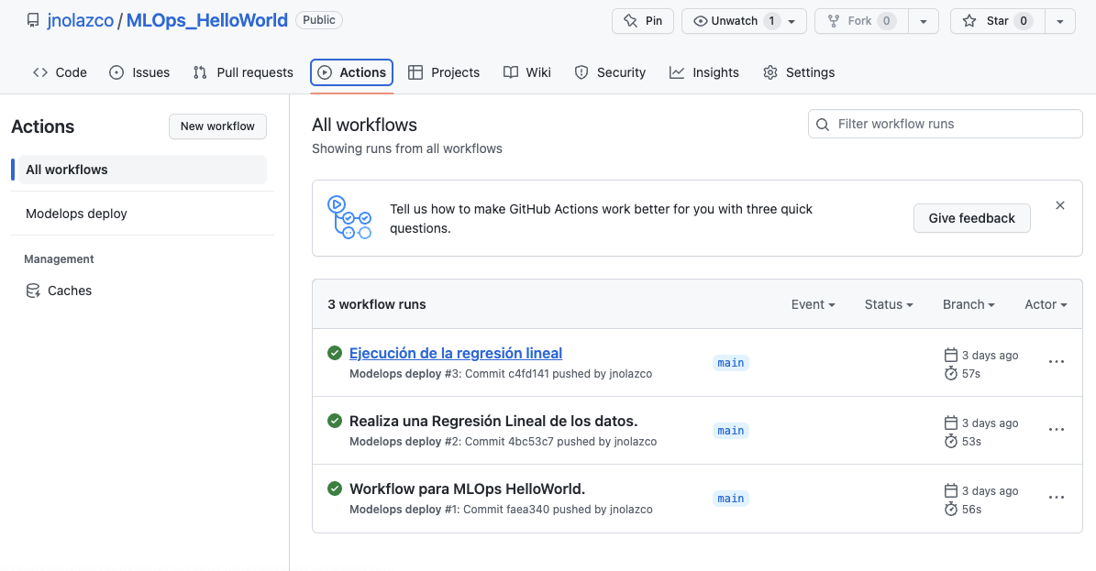

Figure 14. Commit name specification.

4.- Step-by-step workflow execution

4.1, *click* on the last Workflow we execute (first on the list), in this case “**Ejecución de la regression lineal**”:

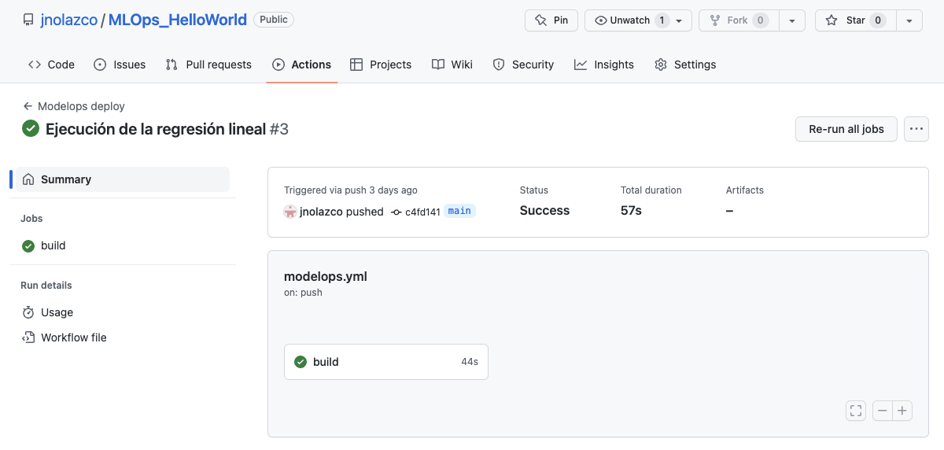

4.2 click on button ***build***, to run a step-by-step execution of the workflow:

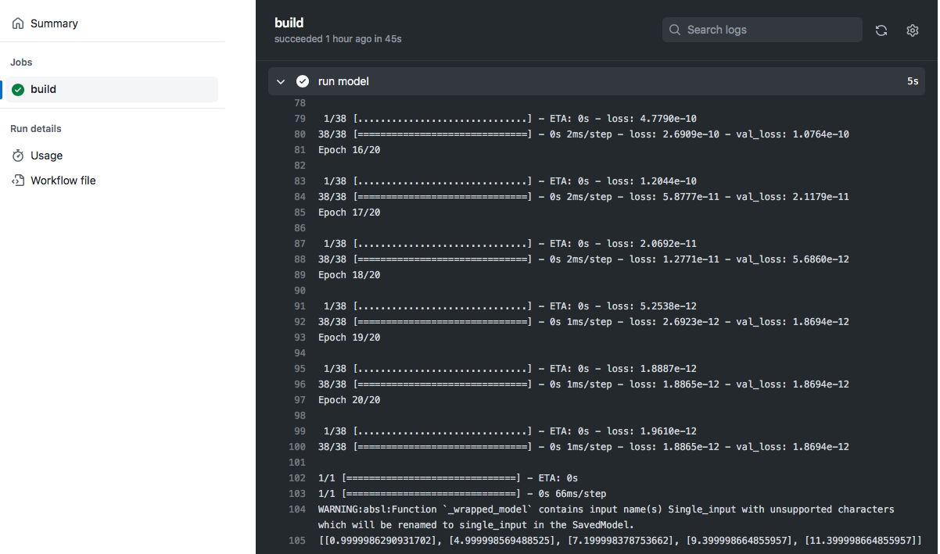

**Chapter: Create an application image and publish on Dockerhub**

At this stage we have created a docker worflow that set an environment to run, train a linear data model and execute it, however this model only exist when the workflow is running.

To store the application image (created model), we need to generate a docker image to store it and load it on the dockerhub image repository.

1.- Log in on Docker Hub if you already have an account on Docker Hub (https://hub.docker.com/signup) otherwise create an account on this site as shown in Annex D.

2.- Create an access account (called secrets) to Dockerhub from Github.

For security reasons we need to use secret tokens.

2.1 On Github click on **Settings -> Secrets -> Actions -> New Repository Secret.**

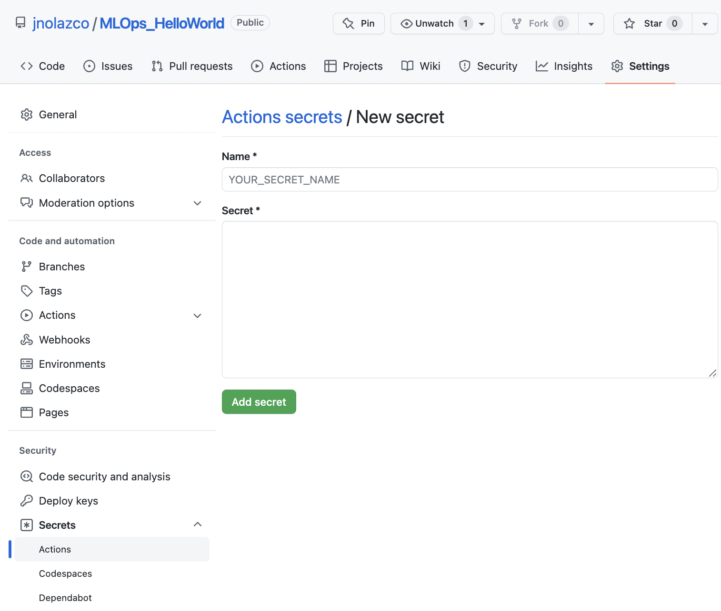

2.2 On “**Name”** field write DOCKER_USER; on “Secret” field write your **user’s name,** in this example adsoft.

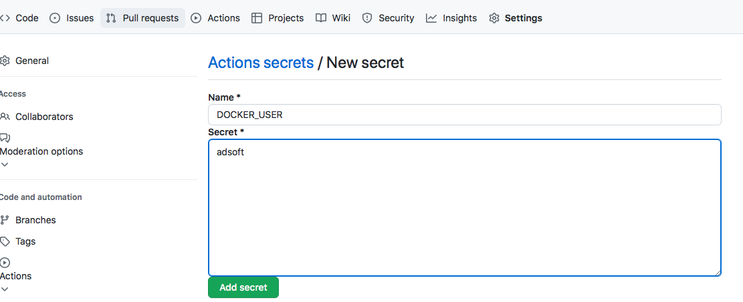

Note: both DOCKER_USER and username will act as variables on Github Workflow acting as Dockerhub credentials.

2.3 Click on the button ***Add Secret***. It appears a **Repository secrets** section with the secret **DOKCER_USER** (figure).

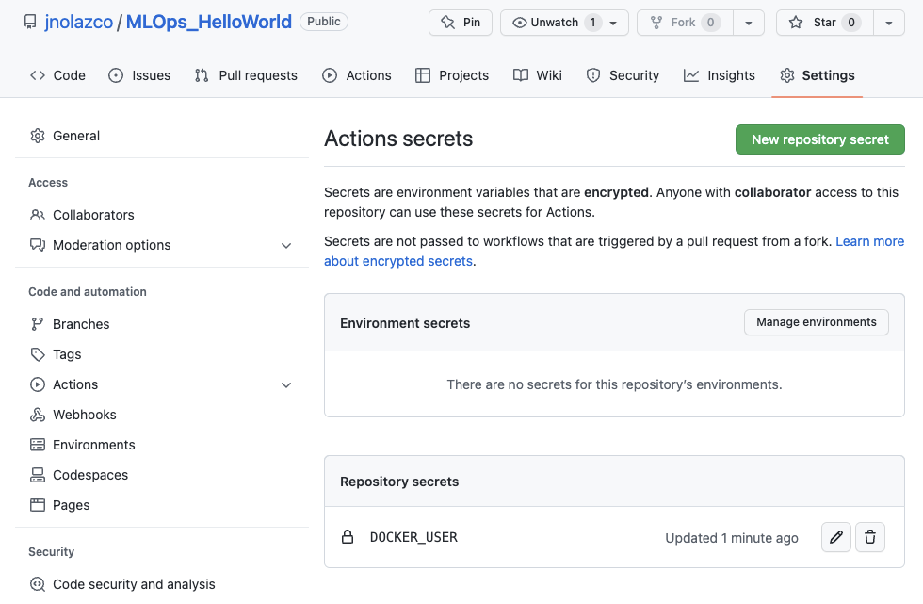

3. Create password account (Secrets) to Dockerhub from Github: .

3.1 On Github click on **New Repository Secret.**

3.2 On Name field ” write DOCKER_PASSWORD; on “Secret” field write your*dockehub-password*. As shown below:

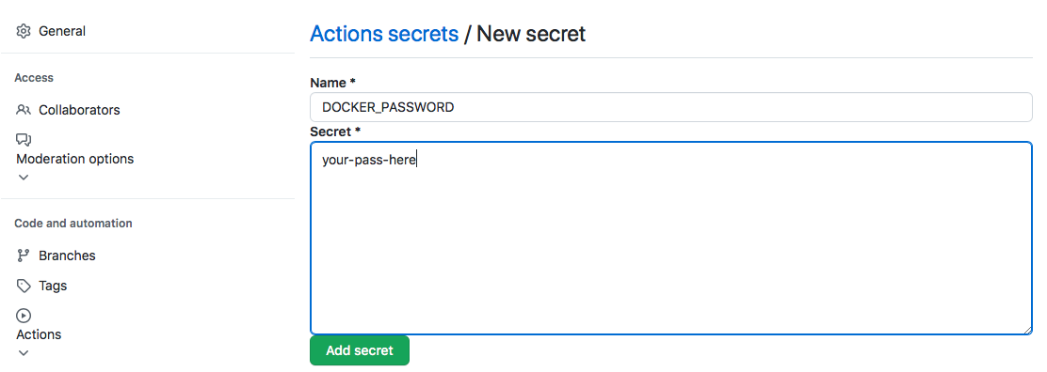

Similarly to the first Secret, both DOCKER_PASSWORD and *dockehub-password* will be used as variables on the Workflow at Github as Dockerhub credential access.

4.- Create an model-name account (Secrets) to Dockerhub from Github Workflow.

4.1.- On Github click on **New Repository Secret.** On Name field ” write MODEL_NAME and on “Secret” field write the **model’s name**, in this case **linear-model** (figure X).

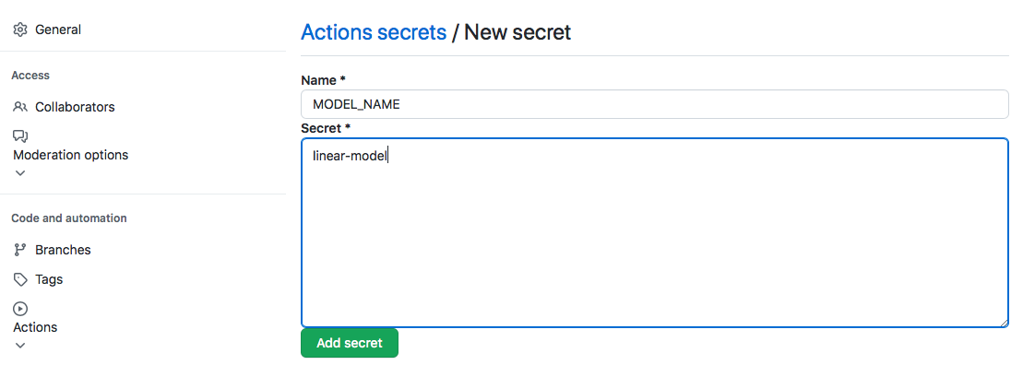

Note: if we want to change the model, we have to edit and fill Secrets section with the new model’s name.

4.- Aggregate **Docker Image** to Workflow:

4.1.- click on <**Code> ->**

**4.2.- .github/workflows**

**4.3.- modelops.yml**

**4.4.- Edit ()** ,

4.5 in “**Edit file”** and inside of ‘steps:’ add code in Annex E (Note: take care of indentation):

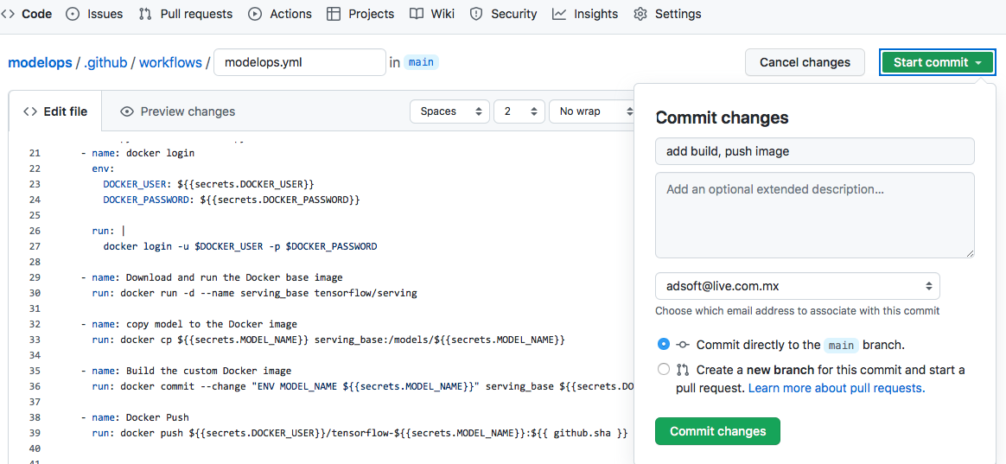

5.- Save changes:

5.1.- Click on the button ***Start Commit***, (figure X) and opens a small form, just below the button, to fill the Commit new file

On Name field write DOCKER_USER; on “Secret” write your **su nombre de usuario (i.e. a00185899)**.

5.2.- Add a comment related to the Workflow function

5.3.- Save change by *clicking* on ***Commit Changes***.

Nota: como realizamos una acción, el workflow se dispara automáticamente. En este caso, la acción fue ejecutar el programa **construir la imagen** y subirla al Docker hub.

**5.-** Verify that Workflow was automatically triggered:

5.1.- On main menu, click on ***Actions***

5.2.- In section “All workflows”, figure 6, you will observe workflow run “**Ejecucion de la regresión lineal**”.



Después, hacer *click* sobre el último workflow que ejecutamos (el primero en la lista),



haga *click* en ***build***, para visualizar; el paso **docker login,** donde se vería que github tuvo acceso a dockerhub; después vemos **Download and run the Docker base image,** donde se verían la ejecución del comando **tensorflow/serving** que tiene como objetivo bajar una imagen limpia de tensorflow y python al docker y después los pone en ejecución en memoria RAM; el siguiente paso es la ejecución de **copy model to the Docker image** que tiene como objetivo copiar el modelo ya entrenado al docker que bajamos en paso anterior y que está ejecutando. El siguiente paso es la ejecución de **Build the Custom Docker Image** que tiene como objetivo construir una imagen modificada con nuestro modelo ya entrenado. El último paso es la ejecución de **Docking Push** que tiene como objetivo publicar la imagen hacia Docker Hub para exponerlo como un servicio REST_API que pueda ser consumido por algún cliente.

3.9.- Haga *click* sobre ***model deploy*** y verificar que el workflow tiene en verde el ícono **✔** como se muestra a continuación:

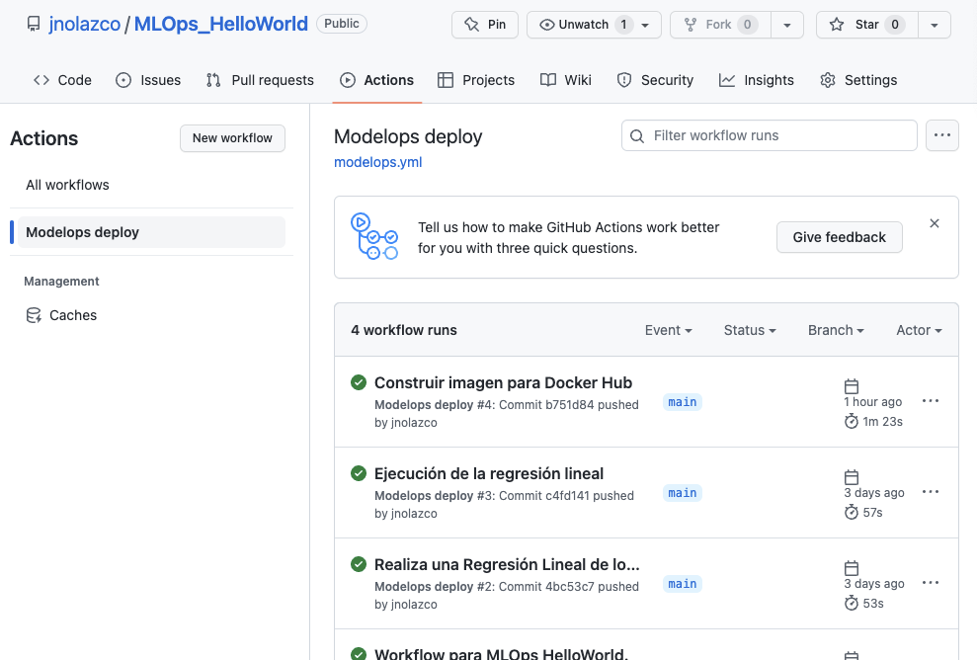

15.- Ir a <https://hub.docker.com/repositories> y verifique que esté publicado. Para este propósito haga *click* en el menú **Repositories** (figure x):

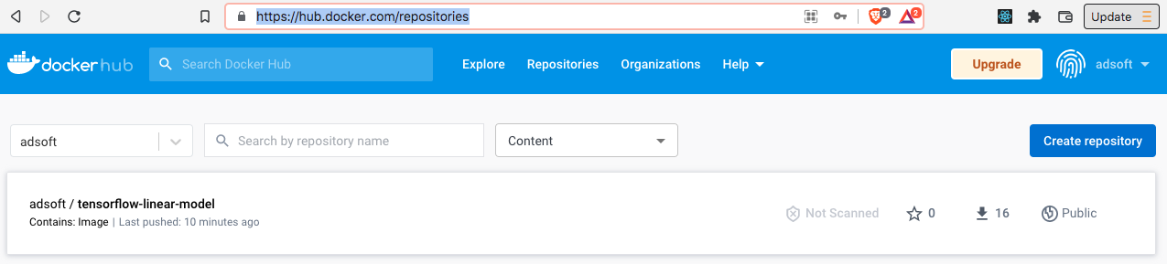

**Capítulo 3: Despliegue de la aplicación del cluster en kubernetes**

1.- Login on Oketo Cloud (Annex H).

2.- Define the name of the *Token* and generate it to access OKTETO from Github Workflow (Annex I)

3. Get Name Space (working area) on OKTETO.

3.1 On lef-side menú click on Namespaces. Note: namespaces is your Github ID converte to lowercase characters.

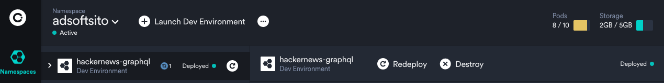

4.- Create an access account (Secrets) to OCTETO from Github Workflow.

4.1 On Github click on **Settings -> Secrets -> Actions -> New Repository Secret.**

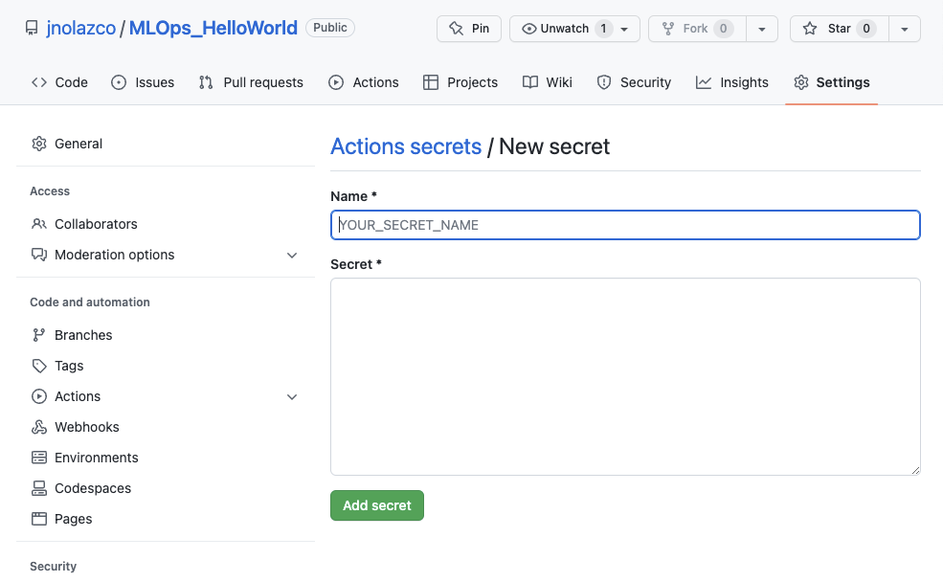

4.2 On “**Name**” field write OKTETO_TOKEN; on “Secret” field write the **Token**.

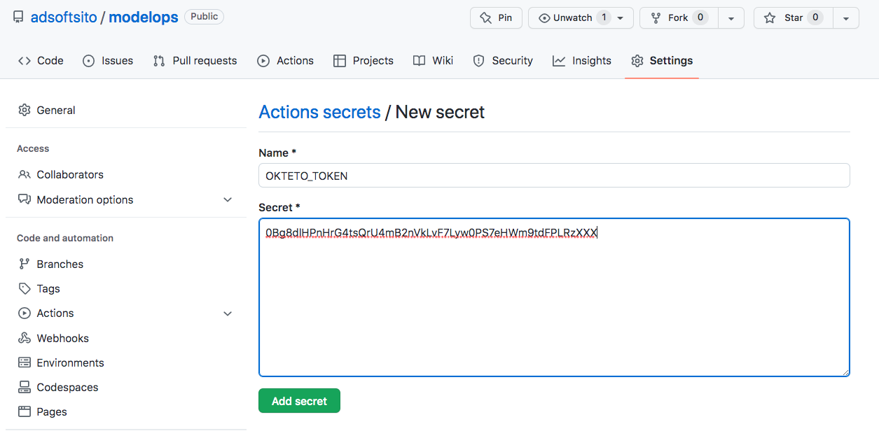

Note: both OKTETO_TOKEN and Token will act as variables on Github Workflow acting as Dockerhub credentials.

4.3 Click on the button ***Add Secret***. Puede observar que en la ventana Repository Secret aparece **OKTETO_TOKEN**, como se muestra en la captura de pantalla:

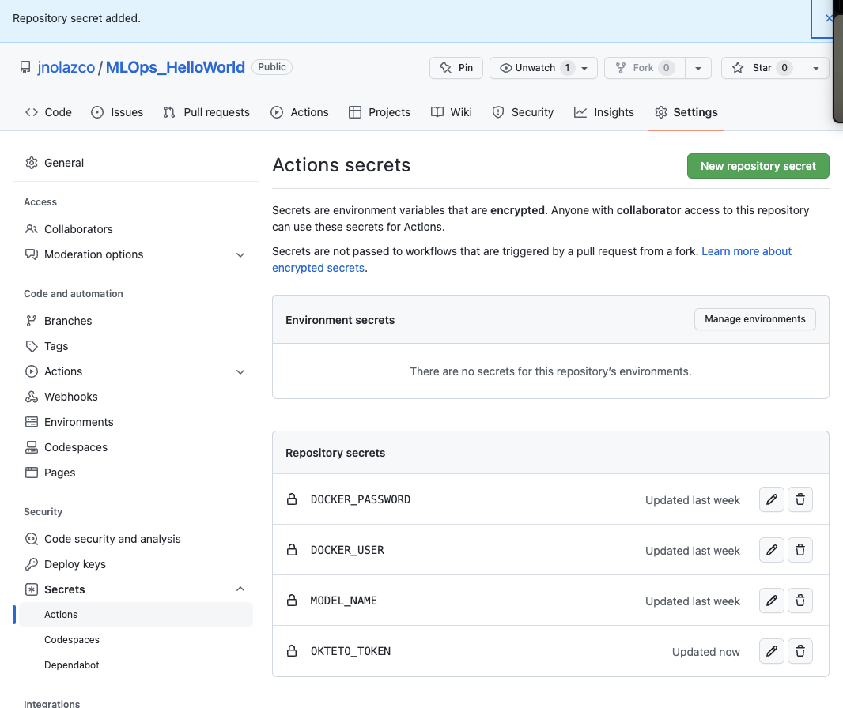

5. Create password (Secrets) to Dockerhub from Github: .

5.1 On Github click on **New Repository Secret.** On Name field ” write DOCKER_PASSWORD and on “Secret” field write your **password**, as in the first secret. As shown below:



Similarly to the first Secret, both DOCKER_PASSWORD and password (del docker hub) will be used as variables on the Workflow at Github as Dockerhub credential access.

6.- Create an Name Space (Secrets) to Dockerhub from Github Workflow.

6.1.- On Github click on **New Repository Secret.** On **Name** field ” write OKTETO_NAMESPACE and on “Secret” field write the **namespace**, in this case **adsoftsito**. As shown below:

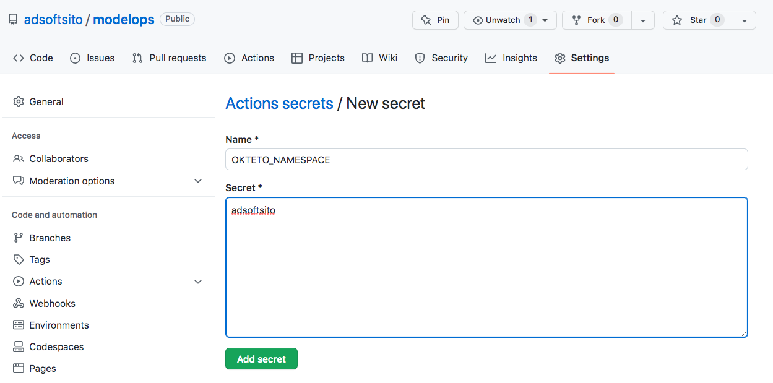

Similarly to the other Secrets, both OKTETO_NAMESPACE and **namespace** will be used as variables on the Workflow at Github as Dockerhub credential access.

Verify Action Secrets:

11.3 Click on the button ***Add Secret***. Puede observar que en la ventana Repository Secret aparece **OKTETO_NAMESPACE**, como se muestra en la captura de pantalla:

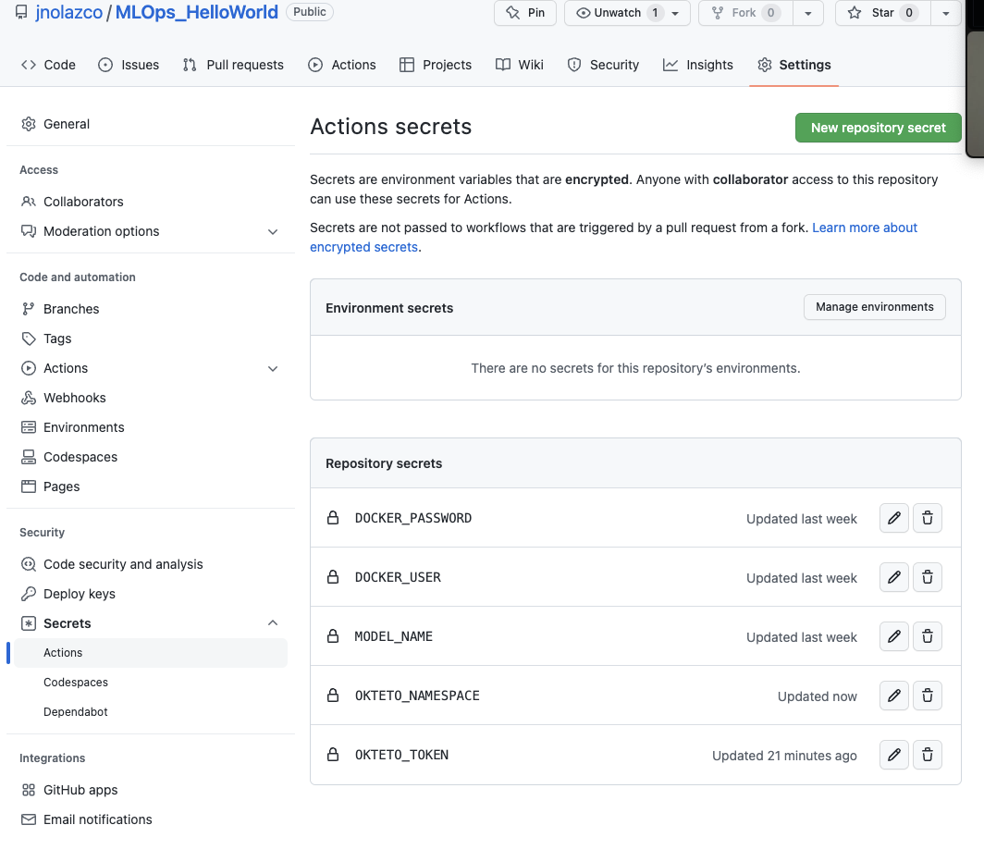

[Kubernetes](https://kubernetes.io/) is an open source platform for **container orchestration** that allows to deploy and manage applications built out of multiple self-conteined runtimes called containers

**1. Create a file to initialize Kubernetes on the workflow, and that will eventually will allow create a cluster with docker’s images replicas which are available in dockerhub:**

1.1.- Clicks on buttons: ***<Code> -> Add File -> Create New File*** to have the form to create a file (figure X)

Figure X. Commit name specification.

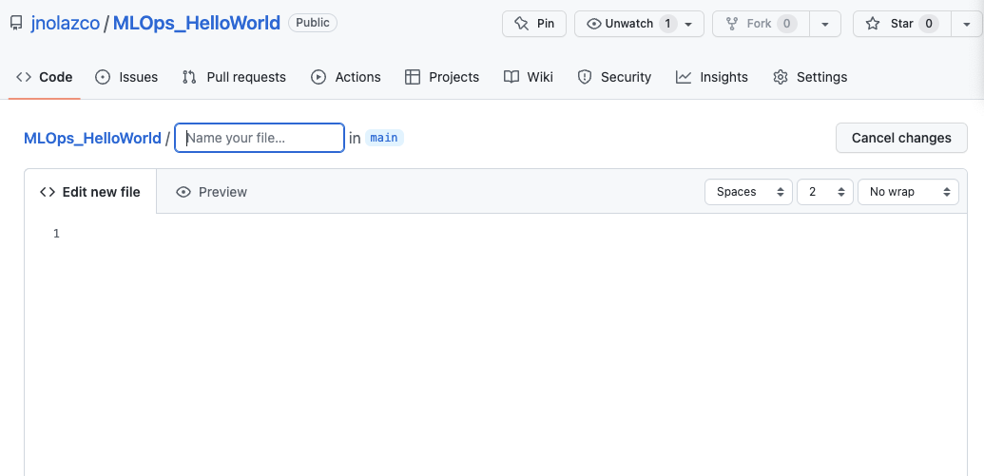

1.2.- In figure X, fill the spaces after “adsoftsito/” with the yml file name, in this case we will use the name **okteto.yml.**

XYZ

Figure 10. Form to create a <Code> file.

1.3.-Replace contect of section **“Edit new file”**, figure X, with the next yml code (Nota: cuidar la indentación):

deploy: # ¿name of the job?

- kubectl apply -f manifests # create all the resources in kubernetes

as shown below:

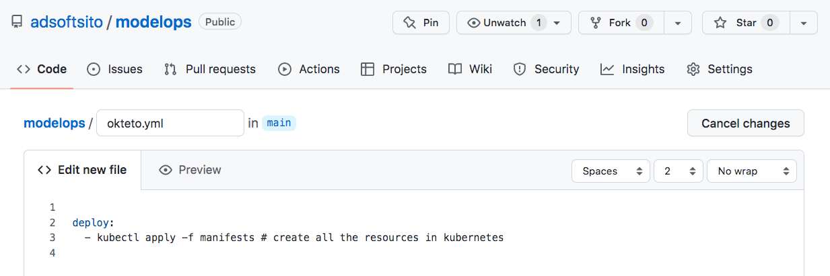

1.4.- Fill a comment on blank spaces at section “**Commit new file**” (at the end of section **“Edit new file”**), i.e. “**add okteto.yml**”;

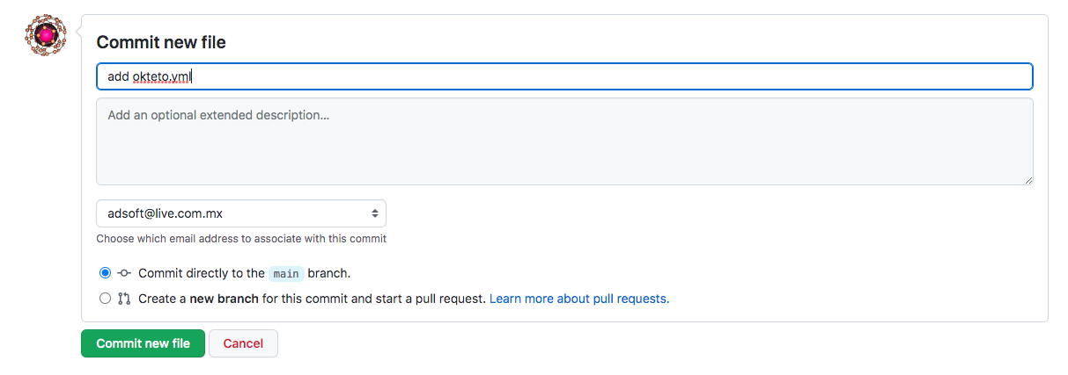

1.5.- save file by clicking on button “***Commit new file***”.

**1. Create a cluster configuration file for Dockerhub:**

1.1.- Clicks on buttons: ***<Code> -> Add File -> Create New File*** to have the form to create a file (figure X)

1.2.- In figure X, fill the spaces after “**manifests**/” with the yml file name, in this case we will use the name **linear_model_k8s.yml.**

XYZ

Figure 10. Form to create a <Code> file.

1.3.-Replace contect of section **“Edit new file”**, figure X, with yml code in Annex D (Nota: cuidar la indentación):

Nota 2: el nombre del archivo está precedido por el nombre de un directorio, ya que puede haber más de un archivo, y el nombre de la carpeta a utilizar es manifests para seguir el “standard ad-hoc” que se utiliza al definir un proyecto):

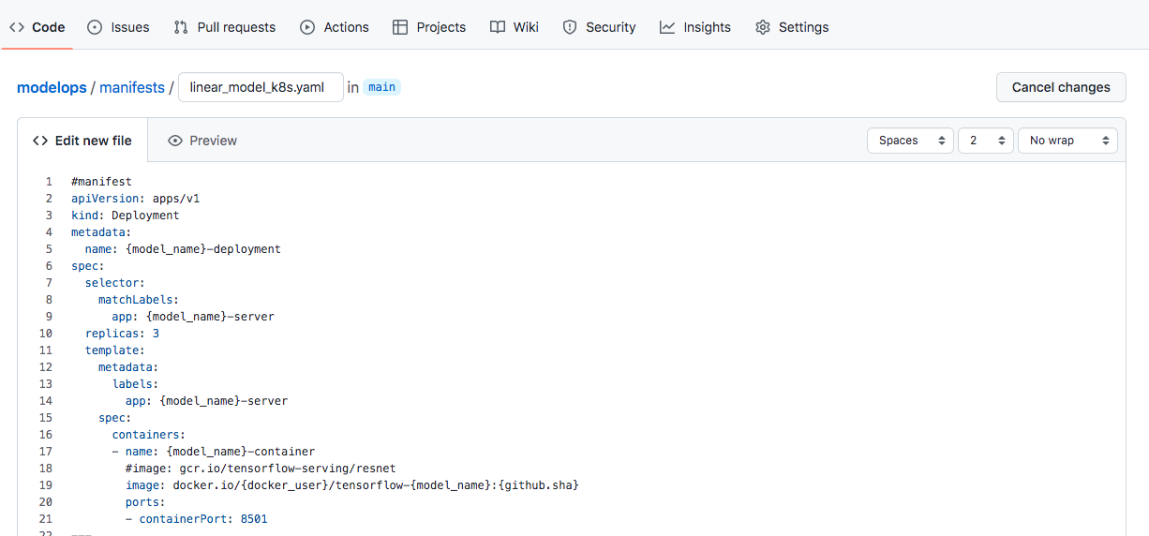

1.4.- Fill a comment on blank spaces at section “**Commit new file**” (at the end of section **“Edit new File”**), i.e. “add file k0.yml” or “Perform a Linear Regression”;

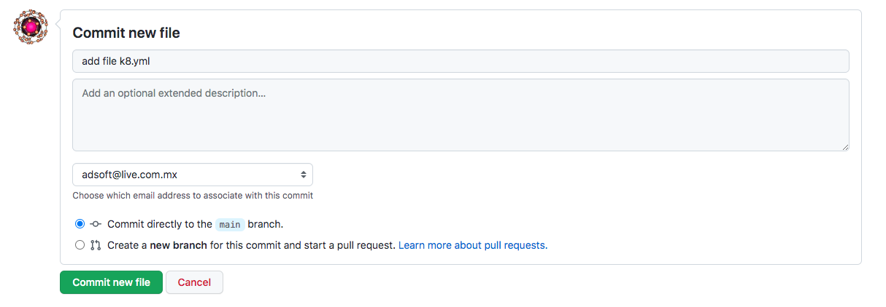

1.5.- save file by clicking on button “***Commit new file***”.

Hasta el momento, el Workflow sigue ejecutando hasta “Hello World” (no será hasta linear prediction?). Los siguientes pasos son para ejecutar el código de Regresión Lineal que acabamos de agregar al repositorio.

2. Save Changes

2.1.- Click on the button ***Start Commit***, (figure 4) and opens a small form, just below the button, to fill the Commit new file

2.2.- Add a comment related to the Workflow function

2.3.- save change by *clicking* on ***Commit Changes***.

Nota: como realizamos una acción, el workflow se dispara automáticamente. En este caso, la acción fue ejecutar el programa “**linear-model.py**”

**3.-** Verify that Workflow was automatically triggered:

Since in our workflow we specify that is automatically triggered, we can verifying following next steps.

3.1.- On main menu, click on ***Actions***

3.2.- In section “All workflows”, figure X, you will observe workflow run “**Ejecución de la Regresion Lineal**”.



Después, hacer *click* sobre el último workflow que ejecutamos (el primero en la lista),



en este caso es ***run model*** y haga *click* en ***build***, para visualizar; el paso **docker login,** donde se vería que github tuvo acceso a dockerhub; después vemos **Download and run the Docker base image,** donde se verían la ejecución del comando **tensorflow/serving** que tiene como objetivo bajar una imagen limpia de tensorflow y python al docker y después los pone en ejecución en memoria RAM; el siguiente paso es la ejecución de **copy model to the Docker image** que tiene como objetivo copiar el modelo ya entrenado al docker que bajamos en paso anterior y que está ejecutando. El siguiente paso es la ejecución de **Build the Custom Docker Image** que tiene como objetivo construir una imagen modificada con nuestro modelo ya entrenado. El último paso es la ejecución de **Docking Push** que tiene como objetivo publicar la imagen hacia Docker Hub para exponerlo como un servicio REST_API que pueda ser consumido por algún cliente.

3.10.- Haga *click* sobre ***model deploy*** y verificar que el workflow tiene en verde el ícono **✔** como se muestra a continuación:



2.1 click on <**Code> -> .github/workflows -> modelops.ym -> Edit ()** , and inside of ‘steps:’ indentation add code in Annex E (Note: take care of indentation):

2.2 Save changes:

2.2.1.- click on ***Start commit*** and opens a small form, just below the button, to fill the Commit new file

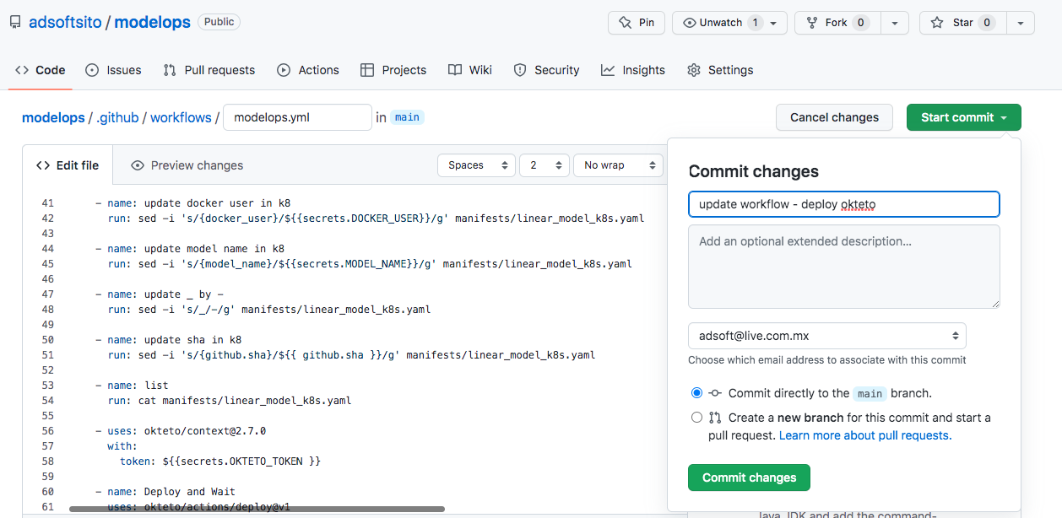

2.2.2.- Add a comment related to the Workflow function, in this case “Se agregó código para hacer el despliegue.”

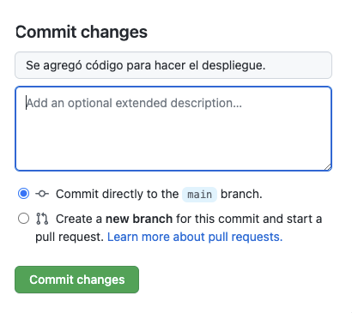

2.2.3.- save change by *clicking* on ***Commite Changes***.

Nota: como realizamos una acción, el workflow se dispara automáticamente. En este caso, la acción fue ejecutar el programa “**linear-model.py**”

**3.-** Verify that Workflow was automatically triggered:

3.1.- On main menu, click on ***Actions***

3.2.- In section “All workflows”, figure 4.1, you will observe workflow run “**Se agregó código para hacer el despliegue.**” is still running.

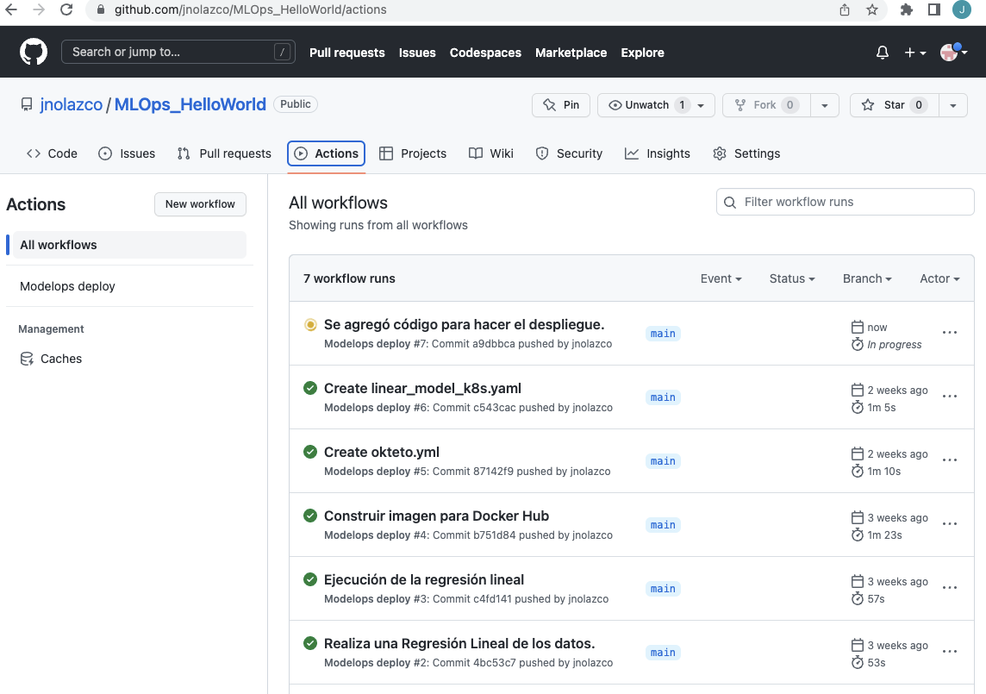

Figure 4.1 All Workflow runs includes “Se agregó código para hacer el despliegue.”.

If we display some minutes later (figure 4.2), we can observe that workflow run already finished:

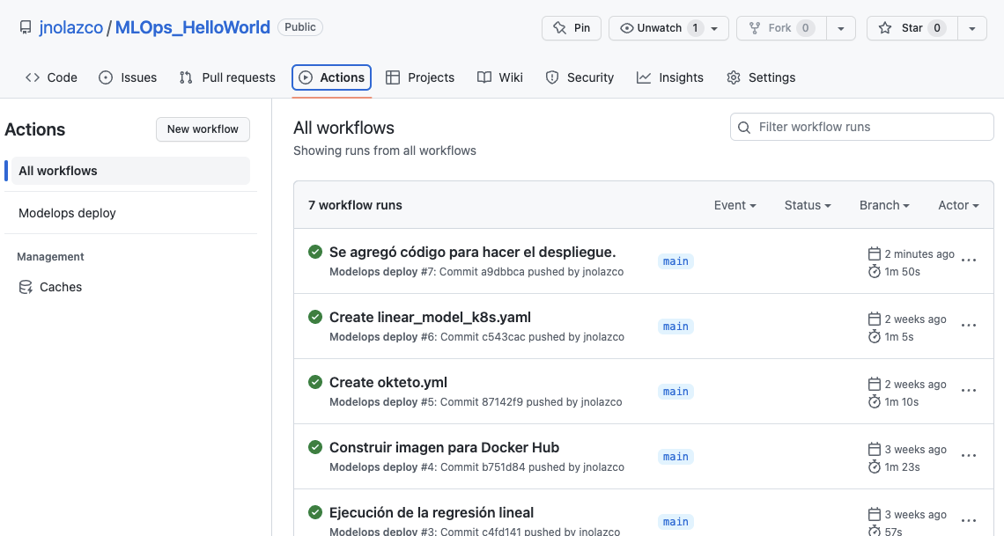

Figure 4.2 Workflows run “Se agregó código para hacer el despliegue.” already finished.

4.- Verifiy that is executing on Okteto

4.1.- Goes to https://cloud.okteto.com/#/spaces/jnolazco

4.2.- You will get a screen as in figure X, where you can observe that X is running.

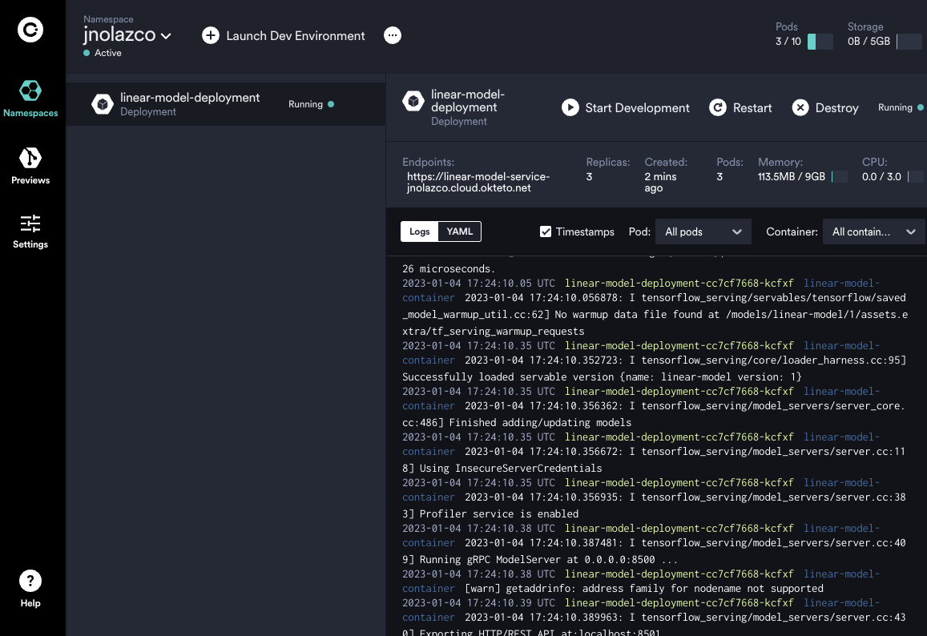

**Chapter: Verify API is working**

We can verify that API is working using POSTMAN (Annex J) or we can use it from a Python code as follows.

1.- Para utilizar el API ejecute el siguiente código en Python ( ***model_client.py*** ) o en Google Colab (***model_client.ipynb***).

import json

import numpy as np

import requests

# The server URL specifies the endpoint of your server running the linear_model

# model with the name "linear_model" and using the predict interface.

SERVER_URL = 'https://linear-model-service-adsoftsito.cloud.okteto.net/v1/models/linear-model:predict'

def main():

predict_request = '{"instances" : [ [0.0], [1.0], [2.0] ]}'

# Send few actual requests and report average latency.

total_time = 0

num_requests = 10

index = 0

for _ in range(num_requests):

response = requests.post(SERVER_URL, data=predict_request)

response.raise_for_status()

total_time += response.elapsed.total_seconds()

prediction = response.json()

print (prediction)

print('Prediction class: {}, avg latency: {} ms'.format(

np.argmax(prediction), (total_time * 1000) / num_requests))

if __name__ == '__main__':

main()

30.- Probar nuestro cliente python.

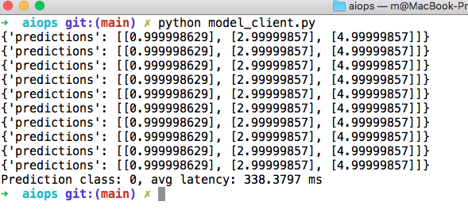

RETO :

* Cambiar la fórmula de nuestro modelo **y = 2x + 10**, por alguna otra que represente algún cálculo de interés en tu carrera.
* Tomando como base ***model_client.py****, construir una app Streamlit que permita capturar los valores a predecir y consuma nuestra API.*

Bibliography:

https://towardsdatascience.com/machine-learning-prediction-in-real-time-using-docker-and-python-rest-apis-with-flask-4235aa2395eb

https://medium.com/geekculture/machine-learning-prediction-in-real-time-using-docker-python-rest-apis-with-flask-and-kubernetes-fae08cd42e67

Annex A:

name: Modelops deploy # The name of your workflow. GitHub displays

# the names of your workflows on your

# repository's "Actions" tab.

on: # It is used to automatically trigger a workflow.

# Triggers the workflow on push or pull request events but only for the "main"

# branch.

push: # Runs the workflow when the push event occurs.

branches: [ main ] # workflow will run when someone pushes to main.

pull_request: # Runs the workflow when activity on a

# pull request in the workflow's

# repository occurs.

branches: [ main ] # filter to configure your workflow to only run

# on pull requests that target specific branches.

# A workflow run is made up of one or more jobs that can run sequentially or in

# parallel.

jobs: # A workflow run is made up of one or more jobs,

# which run in parallel by default. Each job runs

# in a runner environment specified by runs-on.

# This workflow contains a single job called "build".

build:

runs-on: ubuntu-latest # The type of runner that the job will run on.

container: adsoft/aiops:latest # It is used to to create a container to run any

# steps in a job that don't already specify a

# container.

# Steps represent a sequence of tasks that will be executed as part of the job.

steps: # Steps can run commands, run setup tasks, or run

# an action in your repository, a public

# repository, or an action published in a Docker

# registry. Not all steps run actions, but all

# actions run as a step. Each step runs in its own

# process in the runner environment and has access

# to the workspace and filesystem. Because steps

# run in their own process, changes to environment

# variables are not preserved between steps.

# Checks-out your repository under $GITHUB_WORKSPACE, so your job can access it

- uses: actions/checkout@v2 # It will use the actions/checkout github action

# (source [here](https://github.com/actions/checkout)) with the ref checkout@v2. This ref

# only refers to the github action version

# (nothing to do with your repo)

- name: hello-world # A name for your step to display on GitHub

run: echo “hello world workflows …” # It Runs command-line programs using the

# operating system's shell.

Annex B: Python program

import numpy as np

import os

# TensorFlow

import tensorflow as tf

print(tf.__version__)

X = np.arange(-10.0, 10.0, 1e-2)

np.random.shuffle(X)

y = 2.0 * X + 1.0

train_end = int(0.6 * len(X))

test_start = int(0.8 * len(X))

X_train, y_train = X[:train_end], y[:train_end]

X_test, y_test = X[test_start:], y[test_start:]

X_val, y_val = X[train_end:test_start], y[train_end:test_start]

tf.keras.backend.clear_session()

linear_model = tf.keras.models.Sequential([

tf.keras.layers.Dense(units=1, input_shape=[1], name='Single')

])

linear_model.compile(optimizer=tf.keras.optimizers.SGD(), loss=tf.keras.losses.mean_squared_error)

print(linear_model.summary())

linear_model.fit(X_train, y_train, validation_data=(X_val, y_val), epochs=20)

print(linear_model.predict([ [0.0], [2.0], [3.1], [4.2], [5.2] ] ).tolist() )

export_path = 'linear-model/1/'

tf.saved_model.save(linear_model, os.path.join('./',export_path))

Annex D: code to load Docker image in the Workflow

- name: docker login

env:

DOCKER_USER: ${{secrets.DOCKER_USER}}

DOCKER_PASSWORD: ${{secrets.DOCKER_PASSWORD}}

run: |

docker login -u $DOCKER_USER -p $DOCKER_PASSWORD

- name: Download and run the Docker base image

run: docker run -d --name serving_base tensorflow/serving

- name: copy model to the Docker image

run: docker cp ${{secrets.MODEL_NAME}} serving_base:/models/${{secrets.MODEL_NAME}}

- name: Build the custom Docker image

run: docker commit --change "ENV MODEL_NAME ${{secrets.MODEL_NAME}}" serving_base ${{secrets.DOCKER_USER}}/tensorflow-${{secrets.MODEL_NAME}}:${{ github.sha }}

- name: Docker Push

run: docker push ${{secrets.DOCKER_USER}}/tensorflow-${{secrets.MODEL_NAME}}:${{ github.sha }}

Annex D:

#manifest

apiVersion: apps/v1

kind: Deployment

metadata:

name: {model_name}-deployment

spec:

selector:

matchLabels:

app: {model_name}-server

replicas: 3

template:

metadata:

labels:

app: {model_name}-server

spec:

containers:

- name: {model_name}-container

#image: gcr.io/tensorflow-serving/resnet

image: docker.io/{docker_user}/tensorflow-{model_name}:{github.sha}

ports:

- containerPort: 8501

---

apiVersion: v1

kind: Service

metadata:

labels:

run: {model_name}-service

name: {model_name}-service

spec:

ports:

- port: 8501

targetPort: 8501

selector:

app: {model_name}-server

type: LoadBalancer

Annex E:

- name: update docker user in k8

run: sed -i 's/{docker_user}/${{secrets.DOCKER_USER}}/g' manifests/linear_model_k8s.yaml

- name: update model name in k8

run: sed -i 's/{model_name}/${{secrets.MODEL_NAME}}/g' manifests/linear_model_k8s.yaml

- name: update _ by -

run: sed -i 's/_/-/g' manifests/linear_model_k8s.yaml

- name: update sha in k8

run: sed -i 's/{github.sha}/${{ github.sha }}/g' manifests/linear_model_k8s.yaml

- name: list

run: cat manifests/linear_model_k8s.yaml

- uses: okteto/context@2.7.0

with:

token: ${{secrets.OKTETO_TOKEN }}

- name: Deploy and Wait

uses: okteto/actions/deploy@v1

env:

KUBECONFIG: ${{ steps.namespace.outputs.kubeconfig }}

with:

namespace: ${{secrets.OKTETO_NAMESPACE }}

manifest: manifests/linear_model_k8s.yaml

tag: ${{ secrets.DOCKER_USERNAME }}/tensorflow_${{secrets.MODEL_NAME}}:${{ github.sha }}

Annex D:

1. Go to https://hub.docker.com/signup

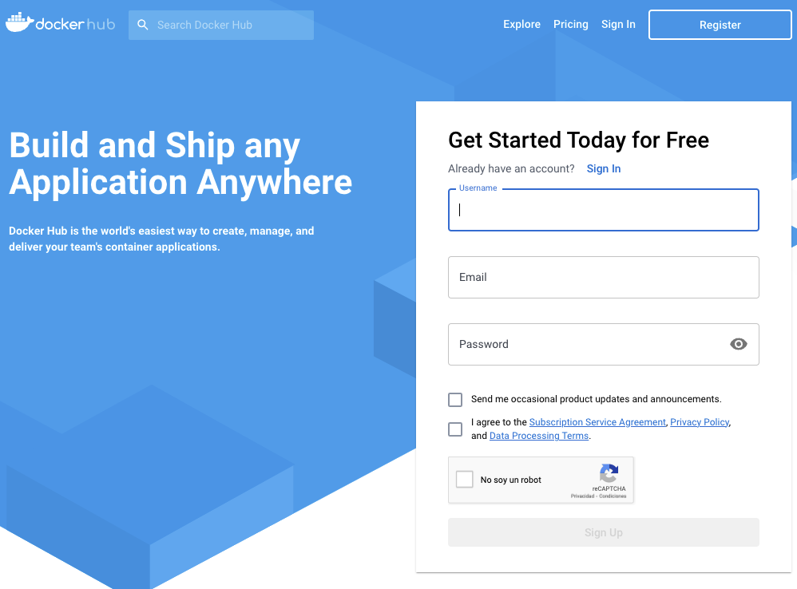

haga *click* en el botón Register y escriba el nombre de Usuario, su cuenta de correo y la contraseña a utilizar para entrar a este sitio, como se muestra en la siguiente captura de pantalla:

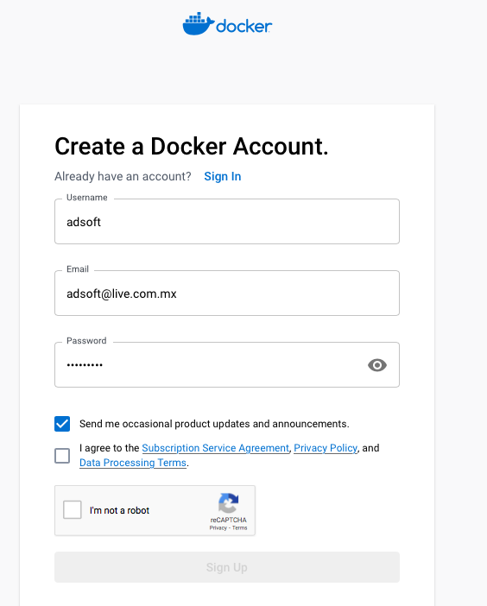

Continue con el proceso y cuando el sitio pregunte el plan de pago, seleccione la opción sin costo.

**Anexo A:** Probamos el API utilizando Postman

En https://www.postman.com/ haga click sobre “Sign Up for Free” y aparece la siguiente pantalla:

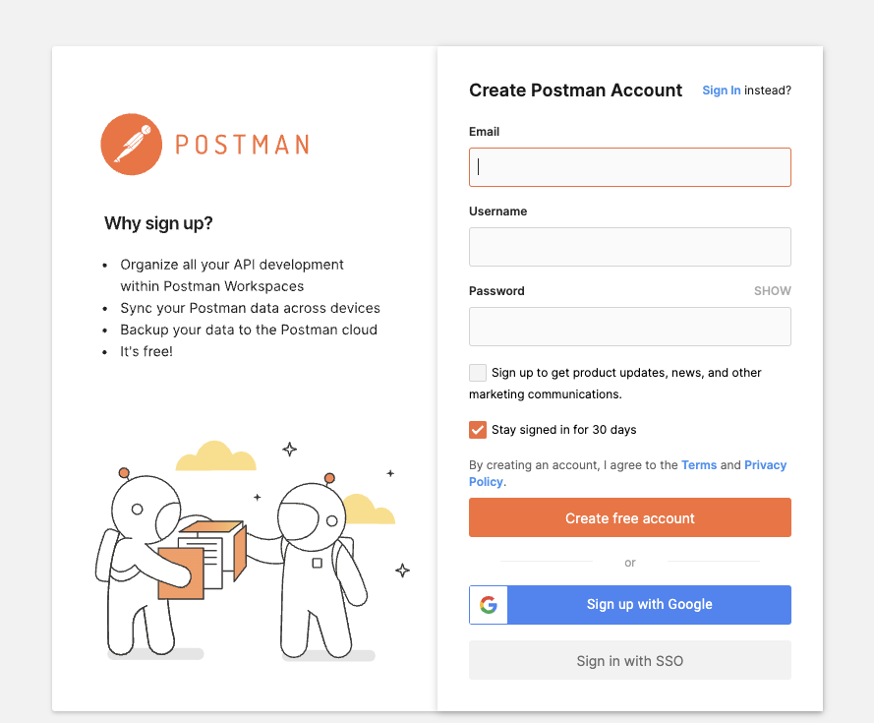

ingrese sus datos, lo más fácil es hacer click en “Sign up with Google”... y eventualmente aparecerá el siguiente botón:

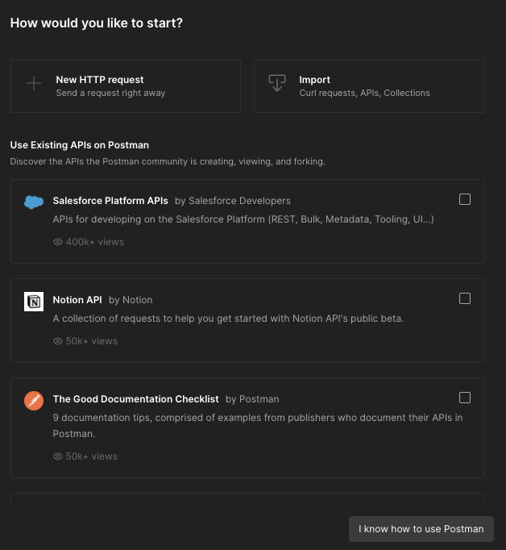

y haga click en “New HTTP request” y se activará en la parte inferior el botón “Continue” y haga click sobre éste botón, y aparecerá la siguiente pantalla:

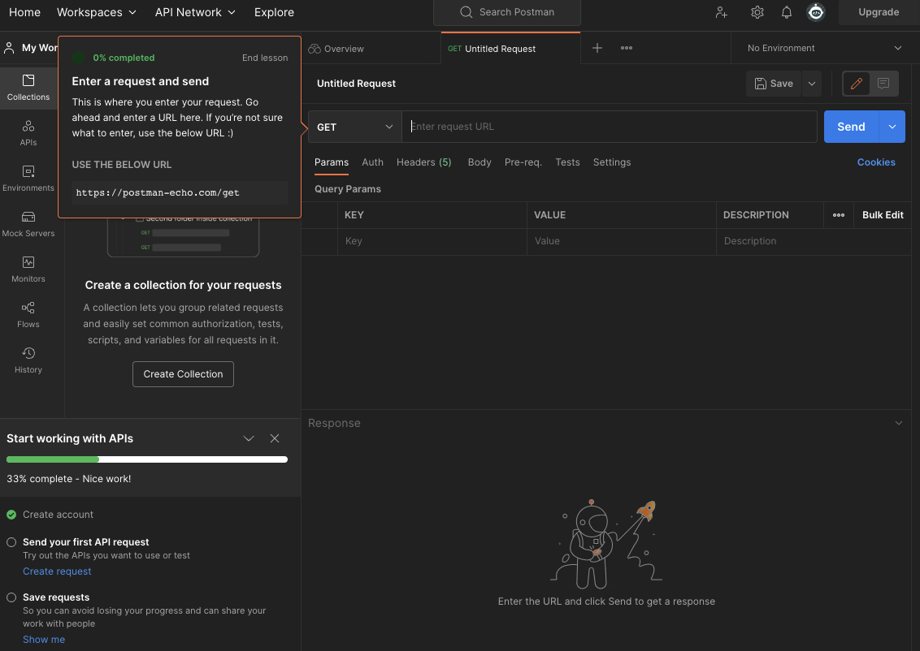

Ya que la llamada a este tipo de servicios son por el método POST, entonces, primeramente cambiamos GET por POST. Ahora, copiamos la dirección URL de la sección “Endpoints” del cluster que está en el sitio Oktetos en los espacios en blanco de la sección POST. Además, a este URL hay que agregarle la carpeta models del docker donde están los modelos (v1/models), así como el nombre del modelo que definimos (linear-model) y finalmente se agrega el método que definimos para ejecutar dentro del modelo (predict). El nombre final del URL sería:

https://linear-model-service-jnolazco.cloud.okteto.net/v1/models/linear-model:predict

como se muestra en la siguiente imagen:

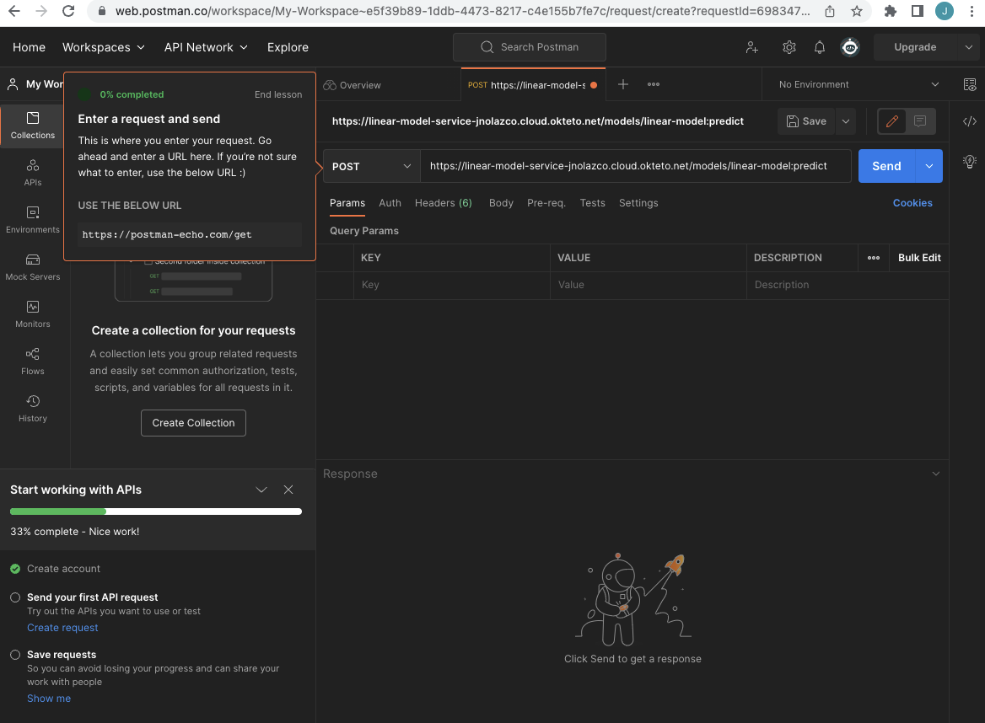

Para enviar el conjunto de datos a evaluar, haga click en “Body”

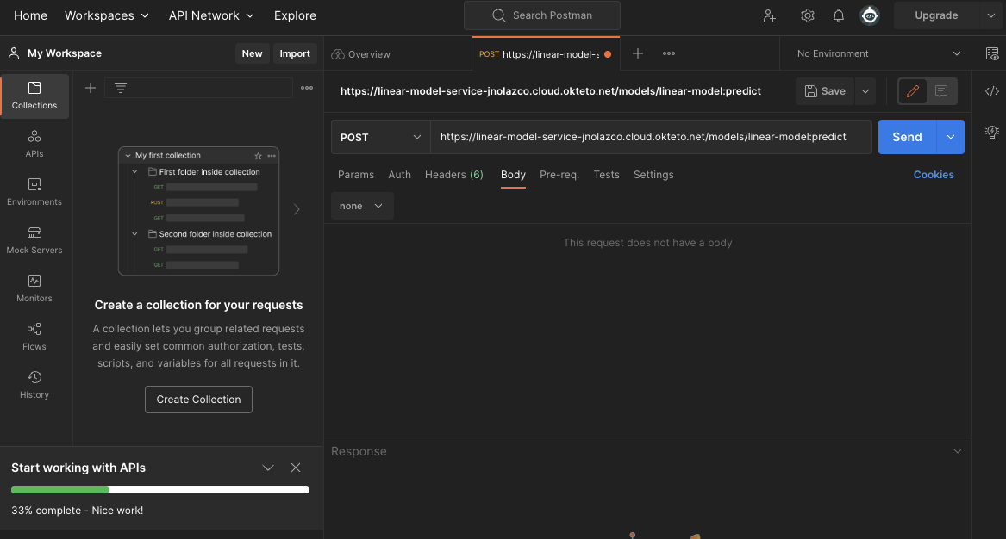

haga click en “None” y seleccione “raw”

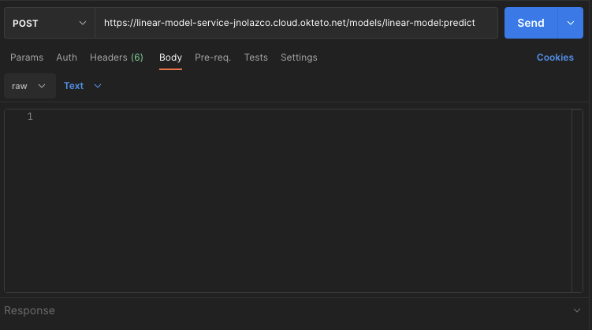

haga click en en “Text” y selecciona “JSON”

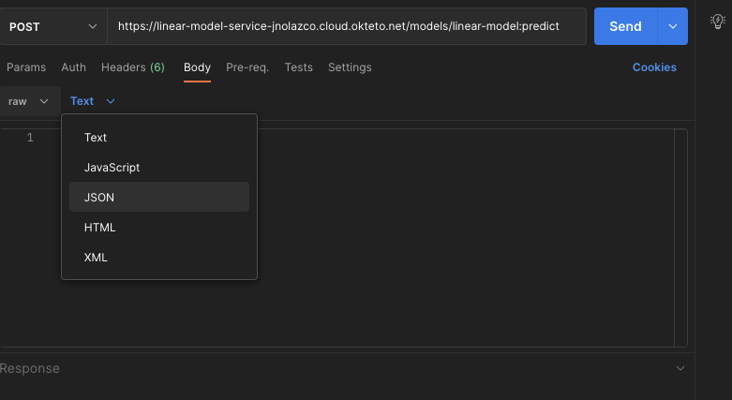

ahora ingrese datos de entrada en formato JASON, en nuestro caso el modelo solo tiene una entrada, entonces sería como se muestra a continuación.: {"instances": [[0.0], [1.0], [2.0] ]}; en caso de que el model tenga dos entradas {"instances": [[0.0, 1.1], [1.0, 2.1], [2.0, 3.8] ]} y así sucesivamente el formato sería como se muestra a continuación:

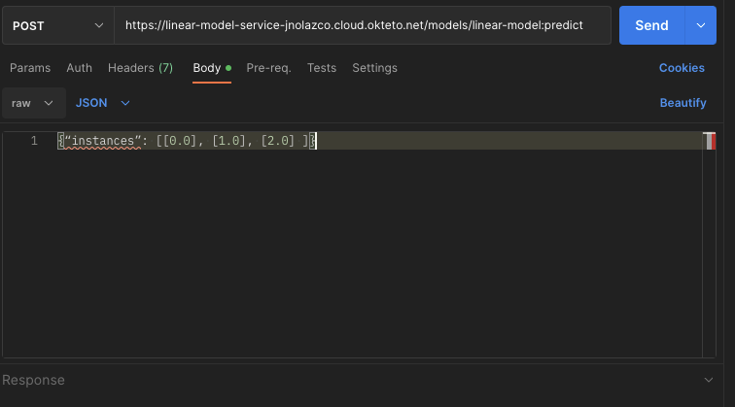

Hacer click en “SEND” y en el recuadro inferior se verá el resultado:

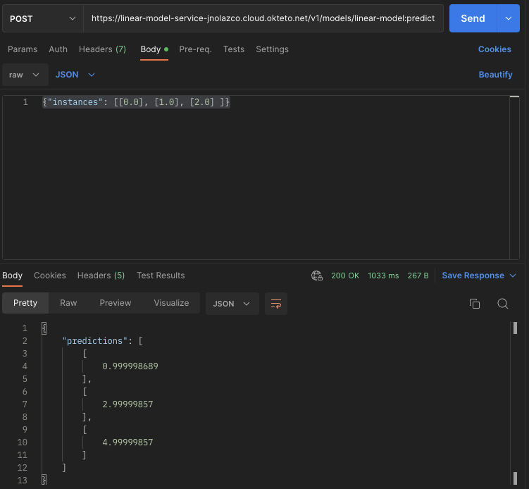

**Annex H: Login Okteto Cloud**

1.- On [this link](https://cloud.okteto.com/#/login) click on button **Log in with GitHub**

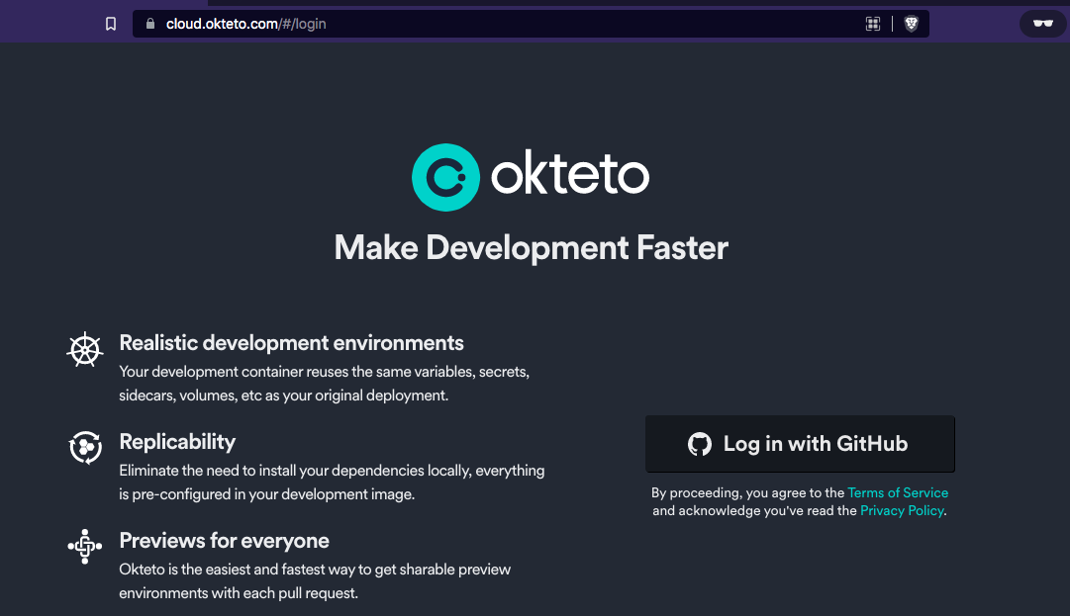

Fill in the spaces with your institutional account[2] to create an account on Octeto cloud

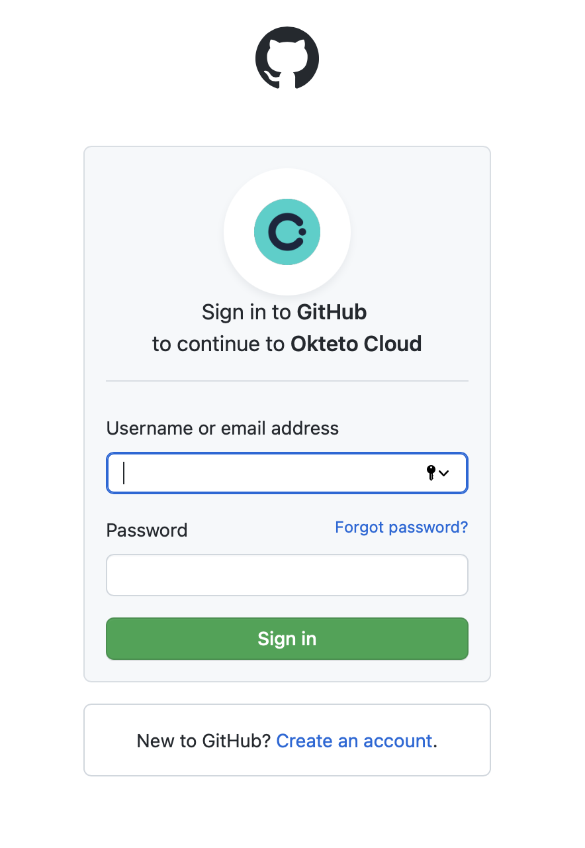

**Note**: if you already have an account in GitHub then when clicking on button “**Log in with GitHub**”, click on button “authorize” your account.

The output screen is shown below:

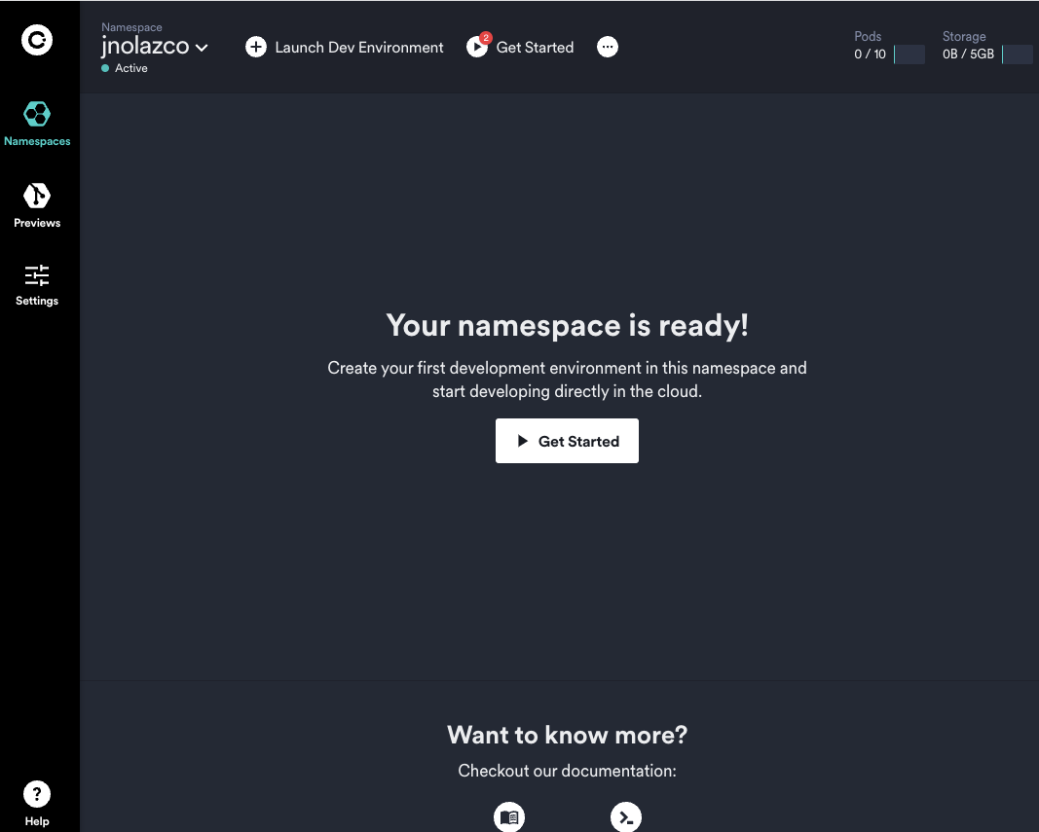

Annex I:

The purpose of this step is to get the token to access Okteto cloud from GitHub Workflow.

2.1 *Click* **settings** on lef-side menu, y aparecerá la pantalla como se muestra a continuación:

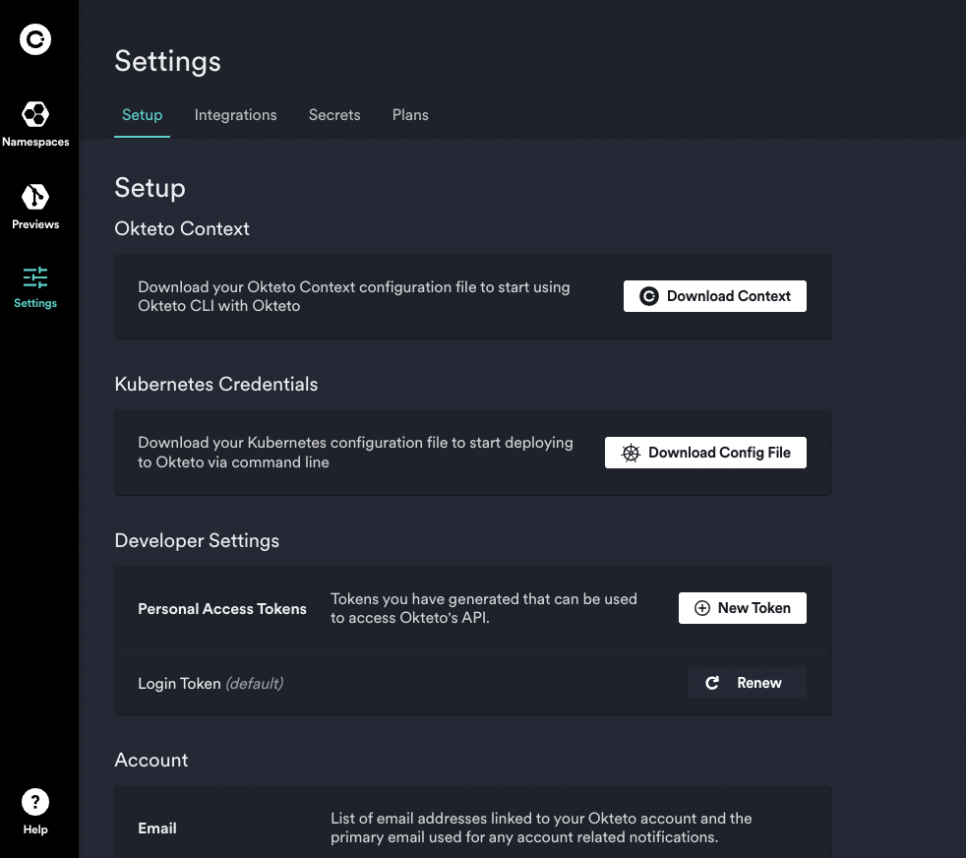

2.2.- On section “Developer Settings”, *click* on button “**New Token”** and appears a button**.**

2.3.- Fill the blank spaces with the name of the token, in this case “Token required to display on GitHub”:

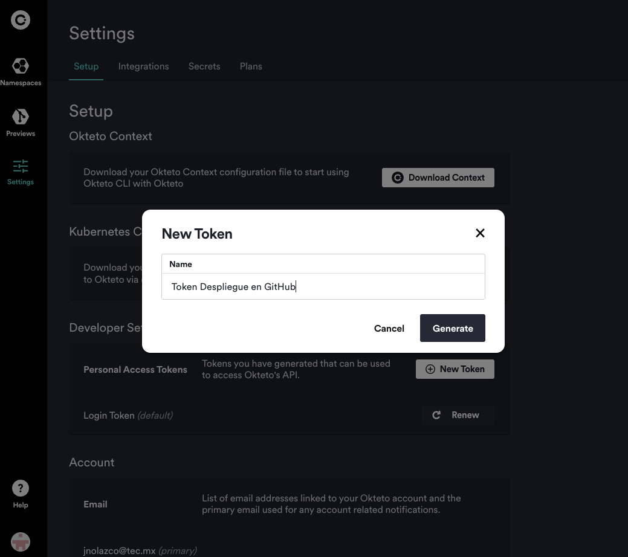

2.4.- Generate token by clicking on button “**Generate**”:

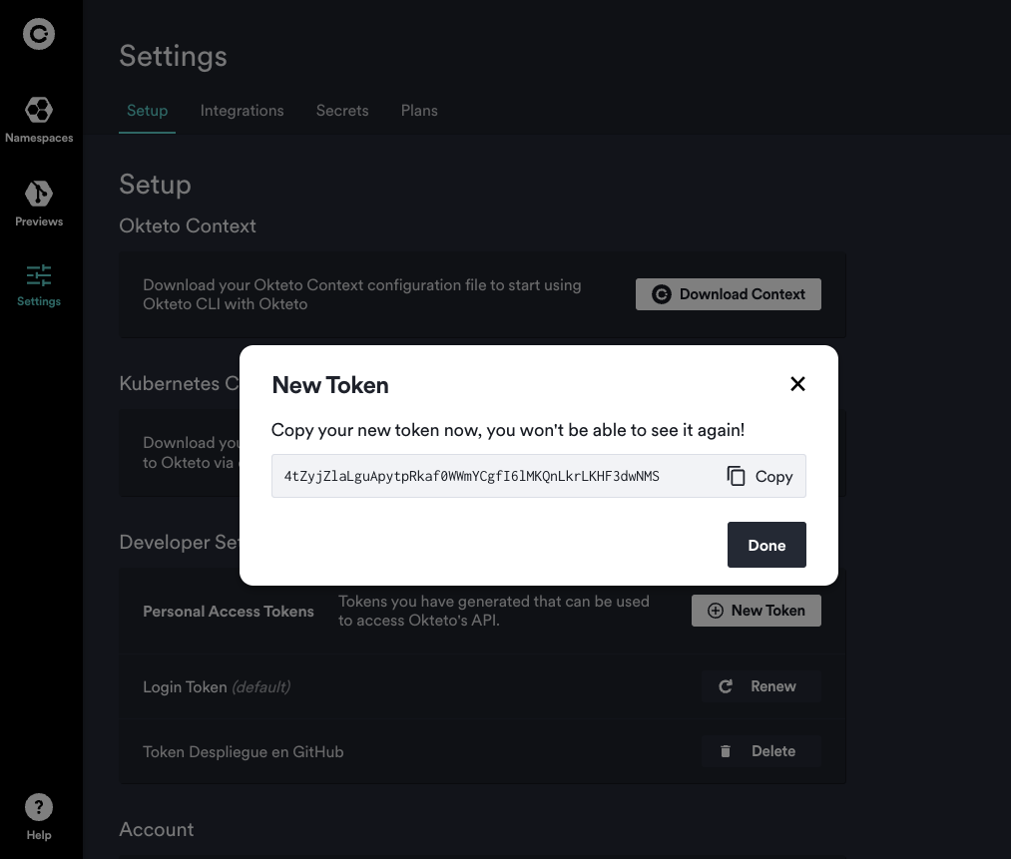

2.5.- **Copy** token by *clicking* on ícon “Copy”

2.6.- Save it on a text file.

2.7.- Click on button “Done” y aparecerá la siguiente pantalla:

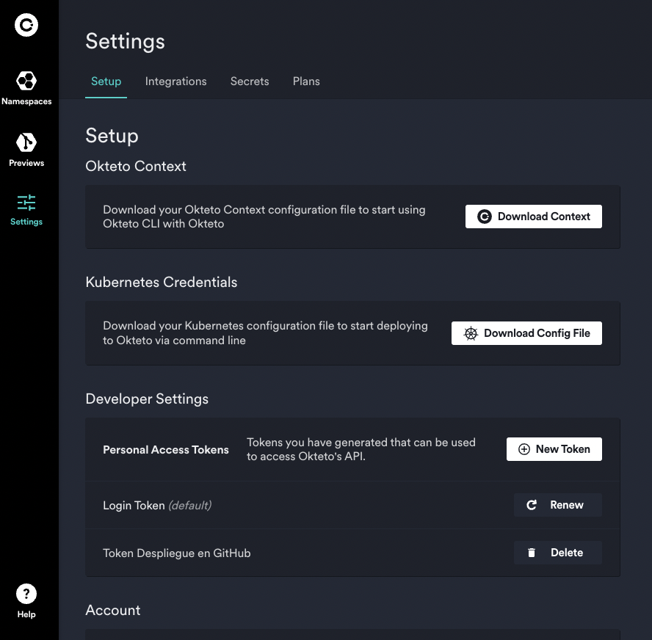

1. De manera similar a cómo una máquina virtual virtualiza (elimina la necesidad de administrar directamente) el hardware del servidor.
2. Octeto no permite cuentas personales, solo permite cuentas institucionales.